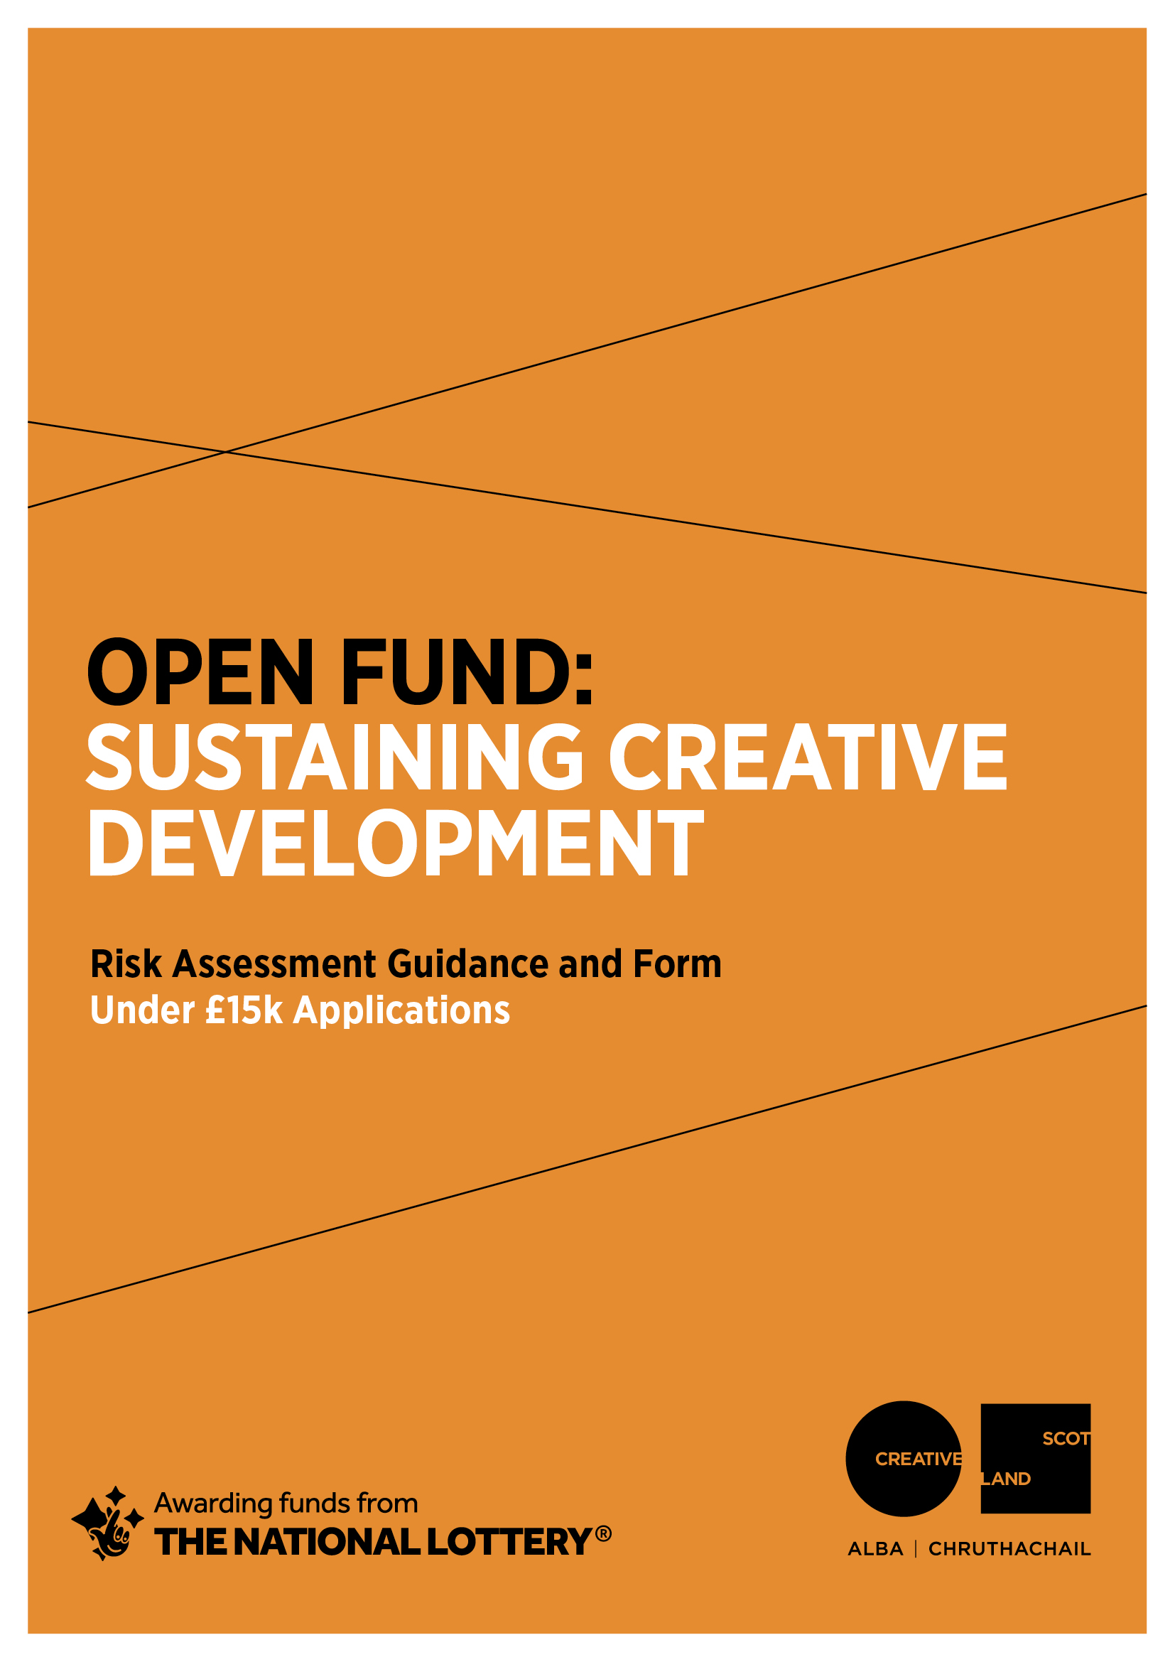

RISK FORMS: Applications for £1,000 to £15,000
Please read the guidance below and fill out the two risk templates at the end of this document: Project/Activity Risk Management and COVID-19 Risk Management. This is a required part of your application.
1. GUIDANCE
1.a. What is risk management?
Risk management means identifying, assessing and taking action to control threats in business or other activity.
1.b. Why do we ask you to assess risk?
We want to help you deliver your project or activity successfully. All activity involves risk. Thinking about risk helps you take action(s) to manage threats to the success of your project or activity. This helps you plan what you want to do.
If you do not think about risk, you may encounter issues that affect you, your project or activity or other people. These issues could be very serious, for example if you fail to think about risks to health and safety.
In many cases risk management allows you to reduce risk a lot. For example some health and safety risks can be reduced by the use of appropriate safety equipment. This reduces the risk to a tolerable level.
Other risks cannot be entirely controlled. You may have to tolerate these risks. Strong risk management helps you to be ready to respond to issues beyond your control should these arise.
Risks to your activity are not just about health and safety – there may be a range of unpredictable elements that could affect the successful delivery of your activity. We want to understand how you are addressing the full range of risks that could affect your ability to deliver the activity that you’re applying to the Open Fund to support.

1.c. How should I manage risk?
There are three steps in managing risk:
- Identify. This means thinking through your project or activity to establish potential threats to its successful delivery.
- Assess. This means thinking about the severity of each risk, and how probable it is that the risk might actually occur.
- Control. This means devising a plan to reduce the likelihood of the risk occurring, and/or to reduce the severity of the effects if the risk occurs.
1.d. How to identify risks
A good way to start identifying risks is to ask yourself, ‘what's the worst that could happen?’ Don’t try to assess these risks as you think of them. Note them down and assess them later.
Example: ‘As an artist my practice is dependent on the use of printing equipment. Failure of my printing equipment is a risk.’
1.e. How to assess risk
In the grid below you will find a ‘traffic light’ system for assessing risk:
RED – this risk might threaten my project being delivered successfully and/or safely
AMBER – this risk is not a threat to safety. It might make my project more difficult to deliver
This risk is GREEN – this risk would not threaten my project being delivered and is not a threat to safety
In the example of the artist, they might think: ‘If my printing press failed, I could not work. This would mean I could not deliver my project. But it is not probable that the risk will occur because my printing press is sturdy and has never failed before. I think this is an AMBER risk in the grid below.’

1.f. How to control risk
Think about ways you can make the risk less severe or less probable. Sometimes you cannot alter both of these factors. For example risk of harm to a person will always be classed as a severe risk, but it can be made less probable by taking health and safety precautions.
In the example of the artist, they might think: ‘I will organise to have access to a press in another studio which will allow me to continue my practice in the event mine fails. I have ensured that these arrangements are available if needs be. This would have costs for me and I have allowed for these in the contingency of my project budget. I think this risk is now GREEN in the grid below. I am comfortable with this level of risk.’
1.g. How to decide if risk is tolerable
GREEN risks are tolerable.
In some cases, AMBER risks may be tolerable. For example, you cannot control the severity of the risk of injury in circus work, only the probability. Some risks may always be AMBER. You may consider this is tolerable.
RED risks are not tolerable. You must take actions to reduce RED risks. This may mean a major re-think of your planned activity.
1.h. Why are there two templates?
Risk is a chance that an issue might arise. If it has become an issue, it is no longer a risk. For example, disruption to business due to a major event such as a pandemic was a risk for performing artists and performing arts organisations prior to March 2020. As of March 2020, this disruption represents a significant issue for them, and for people across the whole of society.
COVID-19 cannot be registered as a risk on your template because it is now an issue. We now need you to think specifically about new risks facing your project or activity, arising from the COVID-19 issue. For this reason we have produced a specific risk form.

2. TEMPLATES
2.1. Project or activity Risk Management Form
One example has been filled out for you.
IDENTIFY RISK | ASSESS RISK (delete/explain) | CONTROL RISK | REVISED RISK ASSESSMENT
50% of income in our project budget is raised through ticket sales. Failure to sell enough tickets is therefore a risk. | This risk is RED  We have the same costs no matter how many tickets we sell. If we lose money we might threaten our business survival. | We will work with an experienced PR on marketing. We have reduced our sales target to be more realistic and are applying for slightly more funding. We have a contingency in our budget. These actions make the risk less severe and less probable. | This risk is now GREEN
 | This risk is RED – this risk might threaten my project being delivered successfully and/or safely  AMBER – this risk is not a threat to safety. It might make my project more difficult to deliver  This risk is GREEN – this risk would not threaten my project being delivered and is not a threat to safety |  | This risk is now RED – this risk might threaten my project being delivered successfully and/or safely  This risk is now AMBER – this risk is not a threat to safety. It might make my project more difficult to deliver  This risk is now GREEN – this risk would not threaten my project being delivered and is not a threat to safety
 | This risk is RED – this risk might threaten my project being delivered successfully and/or safely  AMBER – this risk is not a threat to safety. It might make my project more difficult to deliver  This risk is GREEN – this risk would not threaten my project being delivered and is not a threat to safety |  | This risk is now RED – this risk might threaten my project being delivered successfully and/or safely  This risk is now AMBER – this risk is not a threat to safety. It might make my project more difficult to deliver  This risk is now GREEN – this risk would not threaten my project being delivered and is not a threat to safety
 | This risk is RED – this risk might threaten my project being delivered successfully and/or safely  AMBER – this risk is not a threat to safety. It might make my project more difficult to deliver  This risk is GREEN – this risk would not threaten my project being delivered and is not a threat to safety |  | This risk is now RED – this risk might threaten my project being delivered successfully and/or safely  This risk is now AMBER – this risk is not a threat to safety. It might make my project more difficult to deliver  This risk is now GREEN – this risk would not threaten my project being delivered and is not a threat to safety

2.b. COVID-19 Risk Management Template
COVID-19 is a serious health issue and so risk arising from it is severe. No one can accurately predict the probability of outbreaks. We expect you to follow relevant Scottish and UK government guidance at all times. This table asks you to assess the risks to your planned activity arising from likely government control measures. Consider the risk to your activity going ahead in each case. If the risk is RED or AMBER, you should tell us your alternative plans for how you would deliver your project in these circumstances, e.g. digital back-up plans or rescheduling. You should also tell us about these in the relevant sections of your application form.

Ongoing government measures likely to impact on provision during undefined timescale
 | Identify Risk | Assess Risk (delete/explain) | Control Risk | Revised Risk Assessment
 |  | RED Could not go ahead  AMBER Could go ahead in alternative form  GREEN Unaffected or minimally affected |  | RED Could not go ahead  AMBER Could go ahead in alternative form  GREEN Unaffected or minimally affected
RESTRICTIONS ON PUBLIC GATHERINGS | e.g. We are planning to do all our work online – so there is no risk to public health from public gatherings. | GREEN Unaffected or minimally affected | No control required | GREEN Unaffected or minimally affected
OTHER SOCIAL DISTANCING  (including working-from-home measures, school closures, limited access to healthcare and other provision) | e.g. One of our team is at risk of falling ill if they are exposed to the virus as they are in a high risk health category. | AMBER Could go ahead in alternative form | We have allowed for rest time within the schedule and have planned for this element of the project to be undertaken by another person on the team should they become unable to work. If required, the timeline would be stretched to accommodate a period of absence. | AMBER Could go ahead in alternative form
INTERNATIONAL AND OTHER TRAVEL RESTRICTIONS | e.g. Our project is to attend a conference in Greece in December | RED Could not go ahead | At the moment, this is not possible, however the Government rules on travel to Greece and associated quarantine measures are being adapted. If there are no flights available and international delegates cannot attend, the organizer has agreed to hold all places over to 2021. | AMBER Could go ahead in alternative form
ECONOMIC IMPACT  (supply chain issues, general economic distress) | e.g. My project requires a printer to print and send me a set of patterns which I can sell on my website. At the moment, the printer is still in business but there is a risk that the economic downturn following lockdown may result in the business closing in which case the project would be threatened. | RED Could not go ahead | I am actively sourcing alternative printers, including in other European countries where the pandemic has lessened and businesses are re-starting. I am confident that I can locate a printer to work with if required. I have allowed for a slight increase in cost in the contingency. | AMBER Could go ahead in alternative form

