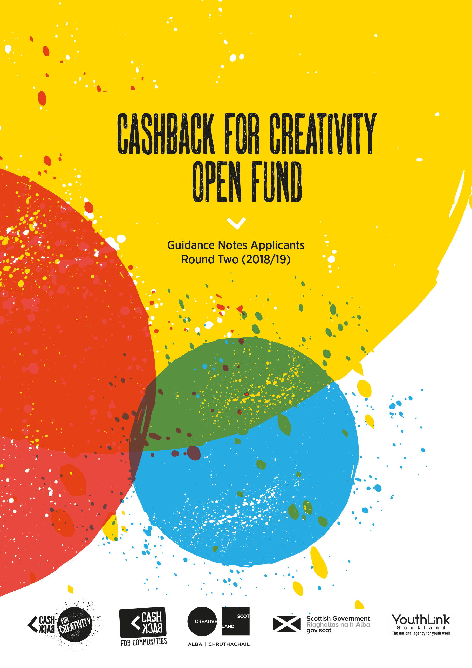

CashBack for Creativity Open Fund

What are we looking for?

The CashBack for Creativity Open Fund will support organisations seeking small amounts of funding so that they can deliver creative activity to young people – primarily those young people who have traditionally found it hardest to access such creative opportunities.

We would like to see applications for projects that provide opportunities to as many young people as possible, should be fun, engaging and accessible. Projects will be expected to engage young people in a short-term project that builds their confidence, self-esteem, and enhances their wellbeing.

Applicant organisations can apply for funding of up to £10k, to deliver up to 12 months of creative activity to young people aged 10-24 (see the Fund Criteria for further information on our specific target groups).

CashBack for Creativity Open Fund Overall Programme

The CashBack for Creativity Open Fund is funded through the Cashback for Communities programme to deliver multi-art form activities to young people across Scotland. Cashback for Communities is a Scottish Government programme which takes funds recovered from the proceeds of crime and invests them into free activities and programmes for young people across Scotland.

There is a total of £250k available in each Round of this Fund. The three Rounds of the Fund will run across the three years of the Cashback for Communities programme (2017 – 2020) as follows:

Round One July 2017 – March 2018
- Projects completed by March 2018. To see details of the 34 projects supported during Round One, go to the Creative Scotland website.

Round Two April 2018 – February 2019
- Applications open 29 November 2017
- Applications close 22 January 2018
- Projects completed and reports to be submitted by March 2019

Round Three April 2019 – February 2020
- Applications open November 2018 TBC
- Projects completed and reports to be submitted by February 2020

Fund Criteria – proposals must:

- Provide high quality arts, screen or creative industries activities for young people living in Scotland ages 10-24 years old who face one or more forms of disadvantage as listed below.
- Living in areas of deprivation (priority will be given to projects working in communities within the top 20% SIMD); and/or
  - Being unemployed, not in education or training; and/or
  - Being excluded, or at risk of exclusion from school; and/or
  - Being at risk of being involved in antisocial behaviour, offending/re-offending

Note: If you aim to target young people living in areas of deprivation, you must:
- Identify the areas
- Demonstrate that it is an area of deprivation
- Demonstrate that young people are from the specified areas.

You can identify areas of deprivation through the Scottish Index of Multiple Deprivation (SIMD).
In Local Authority areas which experience considerable deprivation, the most deprived areas are typically identified as those in the top 20% of datazones (datazone x-y).

If you are delivering activities in Local Authorities which have a very small share of the most deprived datazones, (i.e. has very few datazones which rank amongst the poorest 20% nationally) you should demonstrate that the areas in which you intend to deliver activities are the most deprived in that Local Authority area.

- Offer free, high quality arts, screen or creative industries activities, which encourage young people’s access and participation in one or more of the following art forms: (Dance, Drama / Theatre, Literature / Publishing, Music, Film / Screen, Visual Arts, Multi-Art Form, or other Creative Industries).

- Each proposed project will be expected to achieve the following outcomes for the young people participating:

1: Young people build their capacity and confidence
2: Young people develop their personal and / or physical skills
3: Young people’s behaviours and aspirations change positively
4: Young people’s wellbeing improves
5: Young people contribute positively to their communities
6: Young people participate in positive activity

- Take a proactive approach to ensure the activities are accessible to the target group of young people.

- Fill gaps in provision for young people or add value / build on existing provision
Where appropriate consider joint initiatives with other local providers.

- Support and encourage the involvement of young people in the development, management and running of the project.

- Demonstrate sustainability (whether in attracting other resources or in leaving a legacy).

- Involve qualified and experienced tutors in the delivery of the art activities. (CV’s of delivery staff must be provided).

Who Can Apply

Awards from the fund will be made to organisations in the arts, screen and creative industries, third sector and the youth work sector, who are based in Scotland, working with young people and supporting the delivery of FREE community based arts activities for young people living in Scotland.

Please note - if you are currently funded through any other Creative Scotland funding programme then you are broadly eligible to also apply to this fund, but your application to this fund must be for a project that is distinct from your currently funded project or activity. Funding from the CashBack for Creativity Open Fund can only be used for projects delivered to young people who have had no access to CashBack projects previously.

What we don’t Fund

The CashBack for Creativity Open Fund does not support the following;
- Proposals that do not fit the fund criteria
- Applications from Further / Higher Education institutions or directly from Local Authorities
- Projects where the activities take place during school time and in a school setting – Please note: Cashback for Creativity will not fund anything which is part of a standard school course. Activities within school time will only be considered if they are specifically for young people as specified by the Fund Criteria and the activity is distinct, extra-curricular activity which is delivered by an external source (not the school themselves).
- Events and activities that take place outwith the period of the fund
- Proposals which do not clearly demonstrate high quality arts, screen or creative industries processes and facilitation for the delivery of high quality learning experiences for young people.
- Training Courses for staff and volunteers
- Capital costs in excess of 15% of the total amount requested. (Capital = Property, property upgrades, vehicles, equipment and clothing etc)
- Overseas projects
  - Memberships to private clubs e.g. gyms, golf and bowling clubs
  - Proposals that do not offer good value for money
  - Excessive Management Overheads and Core Cost Recovery

Funding Period

These guidelines relate to Round Two of the CashBack for Creativity Open Fund, and all proposed activities must be delivered between the 1 April 2018 and the 28 February 2019.
All project reports must be completed one month after the completion of the project.

Closing Date for Applications

For Round Two of the CashBack for Creativity Open Fund, there is one deadline.
All applications must be submitted by no later than 1pm, 22 January 2018.
Applicants will be informed of the outcome of their application within 6 weeks of the deadline.

Information you will need to complete your application

To complete the form you will require the following information at hand:
- Bank account details
- Programme budget with detailed workings
- Contact details of;
  - An independent referee
  - The Senior Authorising Officer from your organisation
  - A young person involved with the development of this application

You will also be asked to upload electronic copies of the following documents
- Annual Accounts / Receipts and Payment Statement
- Bank Statements (for organisations who have been operating for less than one year)
- CV’s of any Arts Tutors involved in the delivery of the programme
- Previous evaluation reports (if applicable)

In order to complete the form, the questions we ask will broadly cover the following areas:

You: Tell us about your organisation, how you’re set up, and your main purpose.
The Project: Tell us about the project. What are you hoping to achieve; how were young people involved in the development of the project; and what involvement do you have from the wider community.
Where and when: Tell us where and when the activity will take place
Target Audience: Tell us the numbers of the young people that you hope to reach, and particularly how many you are aiming to achieve the outcomes (as set out in Key Criteria 3)
Staffing/Delivery: Tell us who will be involved in staffing and delivery, their qualifications, and how much time is needed. You’ll also need to tell us how you’ll reach the young people, and whether your project offers any other progression/attainment opportunities.
Budget Information: What is the overall budget and how much are you seeking from the CashBack Open Fund. Tell us about your costs, and any partnership funding or in-kind support you have.

Information on completing the online application

We use an online application process. Once you have logged into the system you can choose to save and return to the application at any point prior to submission. Please take the time to complete every question, the programme does not allow you to progress through the application form otherwise.
There is information and advice provided throughout the application form, please take the time to read this as it will support you to develop a strong proposal.

When completing the Finance and Budget Section of the Application Form please round your costings to the nearest £1. Do not use decimal points or commas. £1523.50 should appear 1524

Once you have completed the form you must select the SUBMIT option, you will then receive email confirmation that your application has been received. If you do not select the SUBMIT option your application cannot be processed or considered by the Assessment Panels.

Should you experience any difficulties with the application process please contact cashback@youthlinkscotland.org

