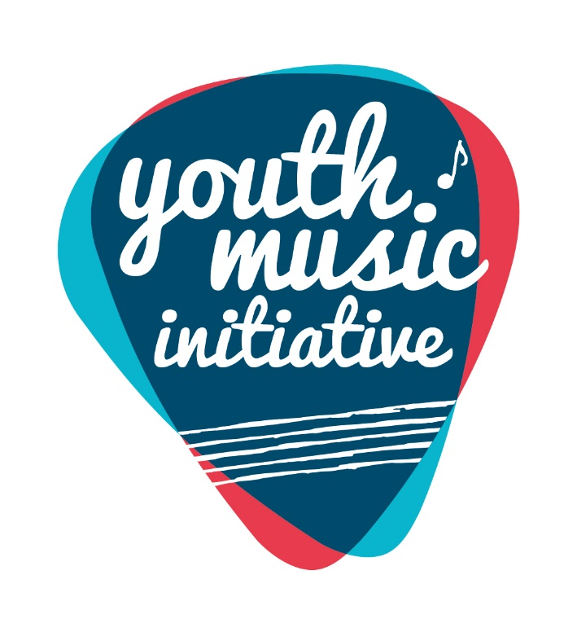

Youth Music Initiative:
Formula Fund Contacts 2023/24

Aberdeen City Council | Beth Edwards | beedwards@aberdeencity.gov.uk
Aberdeenshire Council | Jacqueline Bennett  Kate James | jacqueline.bennett@aberdeenshire.gov.uk  kate.james@aberdeenshire.gov.uk
Angus Council | Elaine Thornton | ThorntonE@angus.gov.uk
Argyll and Bute Council | Catriona Garvin | catriona.garvin2@argyll-bute.gov.uk
City of Edinburgh Council | Linda Lees | linda.lees@edinburgh.gov.uk
Clackmannanshire Council | Mandy Kettles | CLmkettles@glow.sch.uk
Dumfries and Galloway Council | Mel Henry | melanie.henry@dumgal.gov.uk
Dundee City Council | Karen Hamilton | khamilton274@dundeeschools.scot
East Ayrshire Council | Julie Carrie | Julie.Carrie@east-ayrshire.gov.uk
East Dunbartonshire Council | Jane Ferguson | jane.ferguson@eastdunbarton.gov.uk
East Lothian Council | Lesley Smith | lsmith@eastlothian.gov.uk
East Renfrewshire Council | Donald Finlayson | donald.finlayson@eastrenfrewshire.gov.uk
Falkirk Council | Paul Eames | paul.eames@falkirk.gov.uk
Fife Council | Andrew Cowie | Andrew.Cowie@fife.gov.uk
Glasgow City Council | Pamela Black | Pamela.Black@education.glasgow.gov.uk
Highland Council | Norman Bolton | norman.bolton@highland.gov.uk
Inverclyde Council | Lori Ercolino | Lauren.Ercolino@inverclyde.gov.uk
Jordanhill School | Wendy Grant | jo_grantw@jordanhill.glasgow.sch.uk
Midlothian Council | Robert Dick | R.Dick@mgfl.net
Moray Council | Alexander Davidson | Alexander.Davidson@moray/gov.uk
North Ayrshire Council | Ronan Watson | gw09watsonronan@ea.n-ayrshire.sch.uk
North Lanarkshire Council | Kirk Richardson | richardsonki@northlan.gov.uk
Orkney Islands Council | Lynn Proctor | Lynn.Procter@orkney.gov.uk
Perth and Kinross Council | Allan Young | ayoung@pkc.gov.uk
Renfrewshire council | James Cunningham  Mark Traynor | james.cunningham@renfrewshire.gov.uk  mark.traynor@renfrewshire.gov.uk
Scottish Borders Council | Catherine Thomson | Catherine.Thomson@scotborders.gov.uk
Shetland Islands Council | Noelle Henderson | noelle.henderson@sic.shetland.gov.uk
South Ayrshire Council | Shonagh Stevenson | shonagh.stevenson@south-ayrshire.gov.uk
South Lanarkshire Council | Elaine Duffy | elaine.duffy@southlanarkshire.gov.uk
Stirling Council | Clare Hoare | hoarec@stirling.gov.uk
West Dunbartonshire Council | Neil McAllister | Neil.McAllister@west-dunbarton.gov.uk
West Lothian Council | Camille Archer | Camille.Archer@westlothian.gov.uk
Western Isles | Evelyn Coull MacLeod | evelyn@gnes.net

