Youth Arts Fund
2020-21

Small Grants Scheme

End of Project Monitoring Form
for Distributing Organisations*
(updated September 2021)

*Please note this form is for completion by small grants distributing organisations, not for artists to complete

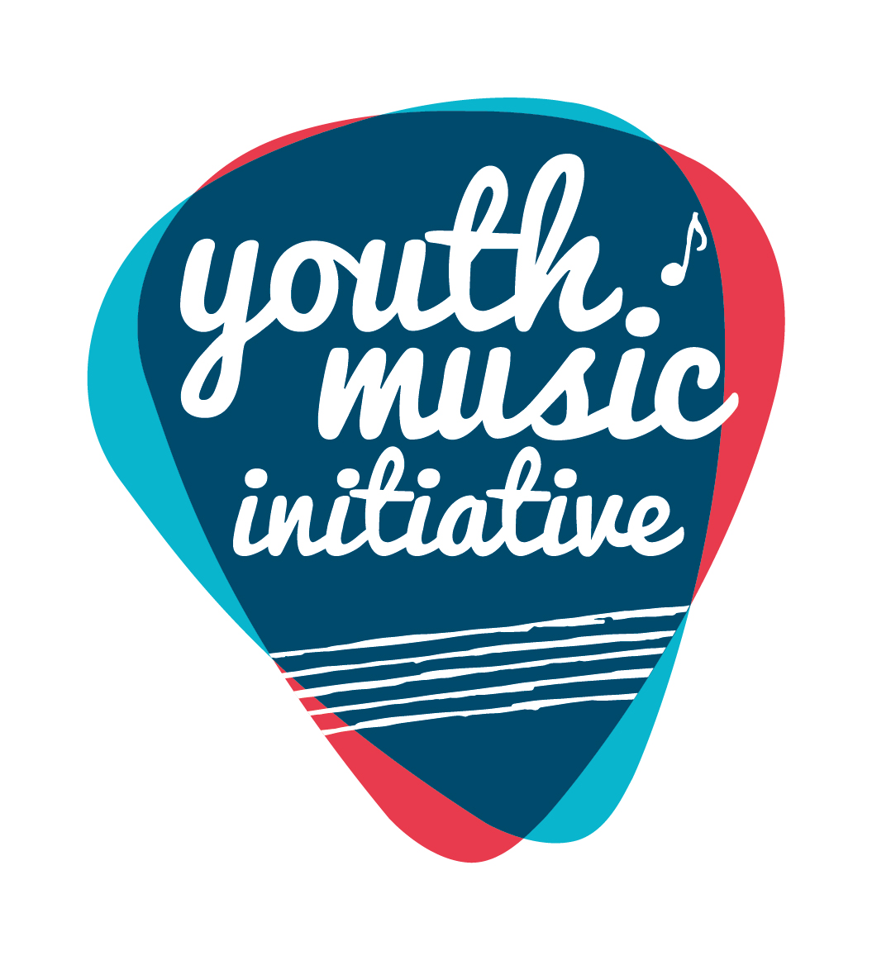
Alternative Formats, Languages and Access Support
Creative Scotland is committed to offering clear and accessible application processes and programmes that are open to everyone. On request this information is available in alternative formats including translations.
We offer access support to disabled applicants, tailored to individual requests. Support includes Sign Language Interpreters for meetings and scribing support for dyslexic applicants. Officers can offer advice to new applicants and support them to make an application. The Equalities Team can offer additional one-to-one support to applicants with access requirements.
Please note we will accept applications and supporting materials which are written in English, Gaelic or Scots.
If you require support, further information or have any general enquiries about the fund and how to apply please contact our Enquiries Service. Our Enquiries Service will be able to advise you or will put you in contact with one of our officers.
You can do this by email, through our website or social media.

Email: enquiries@creativescotland.com
Web: Fill out a form on our website
Twitter: Send us a tweet @creativescots
We aim to respond to all enquiries very promptly. If you want us to call you back, give us your number and we’ll arrange to come back you as soon as possible.
If you are a D/deaf BSL user, you can access our services with the Contact Scotland-BSL programme. Go to: https://contactscotland-bsl.org/deaf-bsl-users/ for more information.
Please note this form was updated in September 2021 in order to reflect the external evaluation approach.

Project Reporting and the external evaluation:

As explained in more detail in the Youth Arts Fund Full Programme Evaluation Guidance document, circulated on behalf of BOP Consulting in September 2021, we would like to ask all funded projects to provide the data relating to their project in two formats:

- The End of Project forms from Creative Scotland for each YAF strand. These will be used to gather the quantitative data for projects funded through the Youth Arts Fund programme. These need to be returned in order to release your final payment. We have updated this form available on our website to highlight the questions that overlap with the external evaluation approach have been highlighted. Here you will be able to choose whether to complete the standard CS form in writing, or to complete the online tool that has been developed by BOP instead, which takes a more creative approach.

- An online Qualitative Evaluation Template. This tool offers you a simple way to share creative content (e.g. pictures, videos, audio) from the projects with us, which you feel best demonstrates the impact of the work you are undertaking with your Youth Arts Fund grant. The tool can be found here: Qualtrics Survey | Qualtrics Experience Management

End of Project forms and any content for the online tool should be submitted by Friday 29th April 2022 at the latest.

If your project activity extends beyond this date, you should submit an Interim Project Monitoring Form and any material you would like to be included on the online tool by 30th April 2022 in order for this to be included in the external evaluation.

Guidance for completing this form
- All questions require an answer unless otherwise indicated. If a question is not relevant to your project/activity, please indicate ‘n/a’.
- If any of your figures are an estimate, or you are unsure of some information at this stage, please indicate this in your answer.
- The word counts are a guide for the approximate maximum amount you should write. We understand all projects/activities are different, please consider the scope of the work you were funded to deliver and share the appropriate level of information with us to provide an understanding of how it went.
- You can submit further evaluative materials (e.g. links, websites/other documents) if you wish to add additional evidence and context to summarise your project/activity.
If you have any questions in completing this form, please contact us at enquiries@creativescotland.com.

What happens once you’ve submitted this form

Completed forms should be submitted to projectreporting@creativescotland.com.

Once submitted, we will log the report and send it to a Creative Scotland officer for checking approval and sign off. Once the form is signed off, Creative Scotland will release the final payment of your grant, as per your funding agreement.
If there are any incomplete or unclear sections, or if we have any further questions, we will be in contact you before approving the form.

Data Protection

Creative Scotland (CS) requires some personal information about you/your organisation to process our funding programmes. If you would like to see a breakdown of the personal information CS requires, why it is required, what CS does with that information and how long CS keeps it, please refer to CS’s Privacy Notice.

CS may share your personal information with third parties to comply with the law and / or for the legitimate interests of CS and / or the third parties concerned. Where the personal information you have provided to CS belongs to other individual(s), please refer to CS’s Privacy Notice. Please ensure you share this Privacy Statement and CS’s Privacy Notice with the respective individual(s).

You have some rights in relation to the personal information that CS holds about you under data protection legislation. Information on how to exercise these rights are contained in CS’s Privacy Notice or you can contact CS’s Data Protection Officer dataprotection@creativescotland.com.

If you have any concerns with how CS has processed your personal information, you should contact CS’s Data Protection Officer in the first instance, as CS would welcome the opportunity to work with you to resolve any complaint. If you are still dissatisfied, you can submit a complaint to the Information Commissioner’s Office.

A: About You

Name of Applicant (Distributing Organisation)
Lead Contact Name
Grant reference number (you will find this on the grant offer letter)
Start date for your small grants distributing programme (this should be your actual start date not your planned start date) | dd/mm/yyyy
End date for small grants programme | dd/mm/yyyy
If these were not the start/end dates originally outlined in your application, please explain briefly the reason for the change. (max 50 words)

B: Overview

- Tell us about your small grants programme – what you delivered and how it went. In question 3 we ask you to tell us a little about the individual projects you supported, here we are looking for you to tell us about implementing the overall small grants programme. (max 500 words)

- Give an overview of the small grants programme you delivered with this funding, including the main successes and challenges.
- If the delivery of your small grants programme was significantly different from your application, please tell us about this and why this was the case.
- Tell us about the decision-making process you implemented and who was involved (including children and young people).
- Tell us how many applications you received for your small grants programme and how many of those were successful.

We ask this question not to compare with the figures in your application form, but to understand the wider demand and activity that this small grants scheme has supported.
How many applications for your small grants programme did you receive?
How many of those applications were successful?

C: Individual Project Details

- Use the table below to briefly summarise each of the projects that took place as a result of the small grants you awarded. Please duplicate the table as required, so that each individual project you supported is summarised in its own table.

Project details
Project number/name
Amount awarded | £
Brief summary: an overview of the activity; how the project was delivered (including if it was online and/or in-person); the freelance artists or creative practitioners that delivered the project.
(max 150 words)
How did the project include the voice of children and young people in project design and delivery? (max 150 words)
List any partners involved in project delivery, such a community or youth groups, and briefly describe each partner’s role.
Postcode(s) and local authority area(s) where the project was delivered.
Priority group(s) that the project specifically and proactively targeted  (delete as appropriate) | Those living in poverty or residing in areas of social and economic deprivation. For more information on the Scottish Index of Multiple Deprivation (SIMD) please visit the Scottish Government website
 | Are experiencing or at risk of experiencing harm and neglect
 | Are looked after (as defined by the Children (Scotland) Act 1995) and care leavers (as defined by the Children and Young People (Scotland) Act 2014). For more information please visit the Scottish Government website
 | Are in the early years (0-5) of their life
 | Are from Black and/or Minority Ethnic backgrounds
 | Have a disability and/or additional support needs
 | Are at risk of offending or have previously offended
 | Are young carers (as defined by the Carers (Scotland) Act 2016) and/or young parents
 | Are experiencing or at risk of homelessness, or who have been homeless
 | Are experiencing mental ill health
Total number of children and young people (0-25 years) involved in the activity.

Please do not double count individuals involved in more than one activity.
Total number of freelance artists or creative practitioners involved in the activity.

Please do not double count individuals involved in more than one activity.
Any further comments you wish to add.
(optional)

Please insert additional tables here as necessary.

D: Impact of the small grants programme

- Tell us about the support you offered for freelance artists and creative practitioners as part of your small grants programme. For example, describe any application support you provided and any mentoring, networking and training that helped freelance artists and creative practitioners to deliver their projects. (max 250 words)
- How many people have benefited from training and continuing professional development linked to your small grants programme?
- Tell us about the impact (the difference the projects made) for the children and young people and the freelance artists and creative practitioners involved. (max 400 words)

You may wish to reflect on:
- Any skills and/or new ways of working for the children and young people.
- The impact on wellbeing and confidence for children and young people.
- Any partnerships, skills and/or new ways of working for the freelance artists and creative practitioners.
Optional: You can choose whether to complete this section in writing, or to complete the following online tool instead, which takes a more creative approach: Qualtrics Survey | Qualtrics Experience Management

- Tell us about the impact that this small grants programme had on you as an organisation. (max 400 words)

You may wish to reflect on:

- Learning gained as result of delivering a small grants programme, for the organisation and for any individual staff.
- The extent to which this project expanded your networks and connections to freelance artists and creative practitioners.
- Any partnership working that this project required and how that went.
- Your role as an organisation in your local community and region and how delivering an arts based small grants scheme has/has not made a difference to that.
Optional: You can choose whether to complete this section in writing, or to complete the following online tool instead, which takes a more creative approach: Qualtrics Survey | Qualtrics Experience Management

- We want to understand the impact that the Covid-19 pandemic has had and continues to have on the delivery of youth arts programmes. Please reflect on whether Covid-19 has impacted on your programme and tell us about any changes and adaptations you have had to make. Include any challenges, new learning, ideas and approaches you will take forward. (max 400 words)

E: Additional Material

[OPTOINAL QUESTION]
- In addition to completing this form, you may wish to share additional material, e.g. website links, social media posts, photos/videos and/or evaluative reports. Please note, this is not a requirement and should only be included if sharing this information provides additional information not articulated in this report.

We would be interested in seeing material that showcases the work of the children and young people, tells the story of the projects/activities and includes the voices and views of children and young people you worked with.

Please see Creative Scotland’s Privacy Policy; if you choose to share content, materials, information that contains personally identifiable information about other individuals, you must comply with Data Protection Laws.

Please use the space below to share any links, briefly describing why you are sharing each one with us and what they evidence/tell us.

If you are sharing further materials as attachments in an email, please list them and briefly describe why you are sharing each one with us and what they evidence/tell us.
Links and why you are sharing them | Optional: You can choose whether to complete this section in writing, or to complete the following online tool instead, which takes a more creative approach: Qualtrics Survey | Qualtrics Experience Management
List any additional materials and why you are sharing them | Optional: You can choose whether to complete this section in writing, or to complete the following online tool instead, which takes a more creative approach: Qualtrics Survey | Qualtrics Experience Management

F: Income and Expenditure

Please provide the following summary budget information and send a certified financial statement using the attached form (See Appendix 1).

9a. Forecast total project expenditure | £
9b. Actual total project expenditure | £
9c. If there were any significant changes (over 10% variation) between actual and forecast figures, please detail these below. If costs increased, please tell us how you managed the shortfall in the space below.

Please note: when the final amount of your grant is calculated, if the project has achieved a surplus of funds because costs have reduced or income from other sources has increased, we will reduce our final payment or ask you to repay any overpaid sums as appropriate.

G: Our Processes

10a. Did you find the application, funding and monitoring/reporting process clear? (delete as appropriate) | Yes / No
10b. Comments (optional)

Please consider the process, communication with and support you’ve had from Creative Scotland.

Signed
A scan of a written signature is acceptable
Date | dd/mm/yyyy

How to submit your end of project monitoring form

For accounting and audit purposes, this form (and particularly the Certified Income and Expenditure statement in Appendix 1) must be physically signed off by the lead contact for the application as being a true and accurate representation of income and expenditure. A scanned or electronic version of this signature is acceptable.

Please either attach your supporting evidence (photographs, videos, audio files, reports) to your email to us, or share links to material in the box in question 9.

Please now email your completed form (with scanned signature) to projectreporting@creativescotland.com

When we receive your report, it will be logged and sent to a Creative Scotland Officer for checking, approval and sign off.

Appendix 1: Certified income and expenditure statement

Name of Applicant (Organisation) |  | Grant reference:
Please include all income and expenditure, both cash and in-kind, using the headings given in your application form and in the same order. Where headings include a number of different types of expenditure, you should provide a breakdown showing how the figure has been arrived at. Please provide explanations of any significant variations between budget and actual (greater than 10%) in the Income and Expenditure section in the end of project monitoring report.
Figures in the budget column should exactly match the figures as stated in the budget submitted in the application form. Any new lines of income or expenditure should be included as a new row (with £0 in the budget column to indicate this is a new income/cost). Additional rows can be added into the table as necessary. If you need to use additional pages please include the grant reference number on each page.
Income |  |  | Expenditure
Source | Budget (£)  This should match the figures in your application | Actual (£) | Item |  | Budget (£)  This should match the figures in your application | Actual (£)
Total |  |  | Total
Total surplus / deficit on the project (actual income less actual expenditure) |  |  |  | £

Signed  A scan of a written signature is accepted |  | Date | dd/mm/yyyy
Print name |  | Position  if signing on behalf of an organisation

