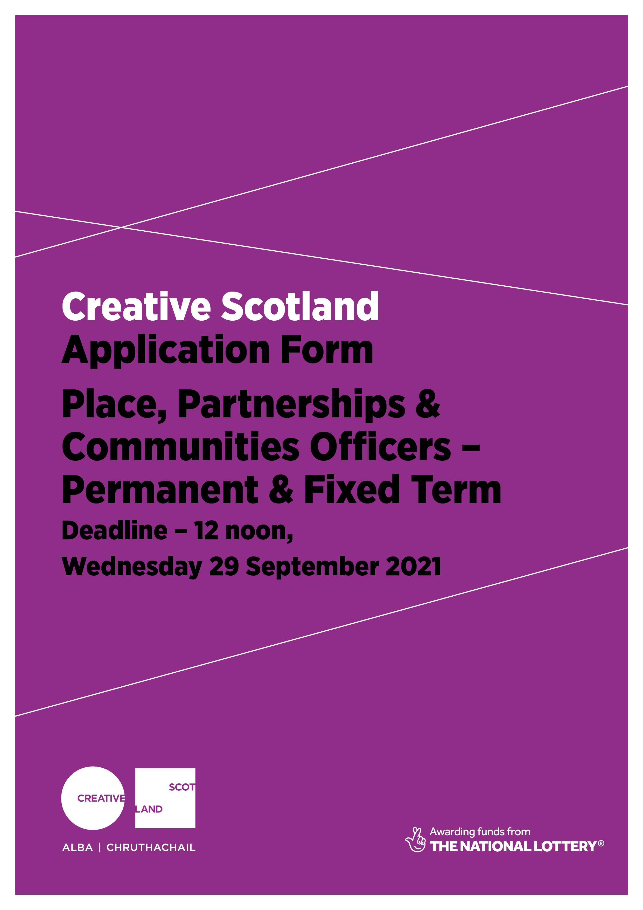

Creative Scotland Application Form

Thank you for your interest in working for Creative Scotland. You must complete the application form and Equal Opportunities Monitoring Form in full as we do not accept CVs and please return to us on or before the deadline date.

Vacancy applying for | Place, Partnerships & Communities Officer
Closing date | 12 noon on Wednesday 29th September 2021

Indicate which role you are interested in:
Permanent | Fixed Term | Both

Applications and Equal Opportunities Monitoring Forms can be submitted in the following ways:

recruitment@creativescotland.com

At Creative Scotland, no applicant will be unfairly discriminated against. We are particularly alert to eliminating discrimination on account of age, cultural / religious / political belief, disability, ethnicity, gender, race, relationship status, sexual orientation, and/or Trade Union membership or stewardship.

Only 'Part B' of this form will be made available to short-listing panel. ‘Parts A & B’ would then be used by the interviewing panel if you are selected for interview.

PART A:

Personal Details
First Name (s):
Surname:
Home Address:
Postcode:
Daytime telephone:
Mobile telephone:
Evening telephone:
Email Address:

The Equality Act 2010
The Equality Act 2010 protects disabled people - including those with long term health conditions, learning disabilities and so called "hidden" disabilities such as dyslexia. If you tell us that you have a disability we can make reasonable adjustments to ensure that any selection processes, including the interview, are fair and equitable.

* Do you consider yourself to have a disability?
◻ Yes ◻ No ◻ I do not wish to disclose this information

Please state the type of impairment which applies to you. People may experience more than one type of impairment, in which case you may indicate more than one. If none of the categories apply, please mark ‘other’.
◻ Physical impairment ◻ Learning Disability/Difficulty
◻ Sensory impairment ◻ Long-standing illness
◻ Mental health condition ◻ Other

If you have a disability, do you wish to be considered under the guaranteed interview scheme if you meet the minimum criteria as specified in the person specification?

◻ Yes ◻ No

PART B:

Employment History
Current or most recent employment
Employer’s name:
Job title: |  | Current salary:
Dates of employment:
Summary of duties:

Reason for leaving

Previous employment
Employer’s name:
Job title: |  | Last salary:
Dates of employment:
Summary of duties:

Reason for leaving

Previous employment
Employer’s name:
Job title: |  | Last salary:
Dates of employment:
Summary of duties:

Reason for leaving

Previous employment
Employer’s name:
Job title: |  | Last salary:
Dates of employment:
Summary of duties:

Reason for leaving

Please continue on a separate sheet if necessary

Qualifications Achieved
Subject | Type of Qualification (e.g. Standard Grade, Higher, BSc etc) | Grade Achieved

Qualifications Currently Studying or Working Towards
Subject | Type of Qualification (e.g. Standard Grade, Higher, BSc etc) | Grade Anticipated | Date Anticipated

 | Membership of Professional or Regulatory Bodies
 | Full name of organization (s) |  | Registration Number | Renewal Date
Competencies and Behaviours
In this section of the application form we ask that you provide evidence of your past behaviour to help us assess your suitability for this role. In each section please give an example that best highlights your effectiveness in the relevant Competency and Behaviour area. You should refer to Creative Scotland’s Competencies and Behaviours which are included within the application pack when completing this section.
Continuous Improvement
Communication
Adaptable and Flexible
Accountability

Why are you applying for this post?

Additional information
Please use this section to give details of any skills or experience not detailed elsewhere and that you consider relevant to this position.

References
Please give the names of two people (one of which should be your current or most recent employer or related to your current course if studying) whom we may approach for a reference.

May we approach your current employer before an offer of employment is made?
Yes/No
Referee 1
Name:
Job Title:
Company Name:
Work Address:
Postcode: |  | Telephone:
Email:
Relationship to you:

Referee 2
Name:
Job Title:
Company Name:
Work Address:
Postcode: |  | Telephone:
Email:
Relationship to you:

Asylum and Immigration Act 1996
The Act makes is an offence to employ an individual who is subject to immigration control and who does not have permission to reside in the UK and undertake paid employment. All offers of employment as conditional on production of documentary evidence of eligibility to work in the UK.

Do you require a work permit to work in the UK? Yes/No

Where did you see this vacancy advertised?

Declaration
I declare that I have read and understood the supporting documentation within the Job Pack including the Recruitment Privacy Notice and that the information given in this form is complete and accurate. I understand that the information recorded on this form will be retained by Creative Scotland purely for the purpose of selection for the post I am applying for and will not be passed to any third party without my permission.

Please note that if applying by email, this email will also be taken as your consent to the above declaration, please type in your name into the signature box to indicate that you have read the declaration.
Signature Date

