Youth Arts Fund
2020-21

Access Fund

End of Project Monitoring Form
(updated September 2021)

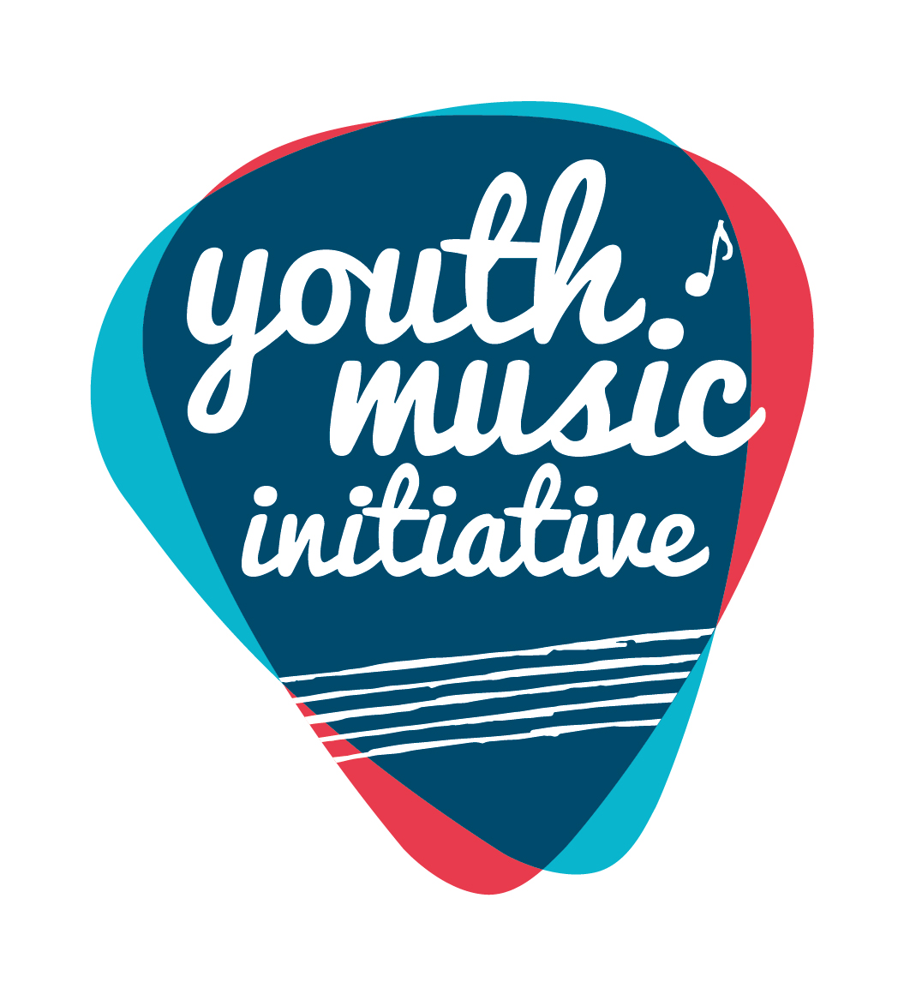
Alternative Formats, Languages and Access Support

Creative Scotland is committed to offering clear and accessible application processes and programmes that are open to everyone. On request this information is available in alternative formats including translations.
We offer access support to disabled applicants, tailored to individual requests. Support includes Sign Language Interpreters for meetings and scribing support for dyslexic applicants. Officers can offer advice to new applicants and support them to make an application. The Equalities Team can offer additional one-to-one support to applicants with access requirements.
Please note we will accept applications and supporting materials which are written in English, Gaelic or Scots.
If you require support, further information or have any general enquiries about the fund and how to apply please contact our Enquiries Service. Our Enquiries Service will be able to advise you or will put you in contact with one of our officers.
You can do this by email, through our website or social media.

Email: enquiries@creativescotland.com
Web: Fill out a form on our website
Twitter: Send us a tweet @creativescots
We aim to respond to all enquiries very promptly. If you want us to call you back, give us your number and we’ll arrange to come back you as soon as possible.
If you are a D/deaf BSL user, you can access our services with the Contact Scotland-BSL programme. Go to: https://contactscotland-bsl.org/deaf-bsl-users/ for more information.

Please note this form was updated in September 2021 in order to reflect the external evaluation approach.

Project Reporting and the external evaluation:

As explained in more detail in the Youth Arts Fund Full Programme Evaluation Guidance document, circulated on behalf of BOP Consulting in September 2021, we would like to ask all funded projects to provide the data relating to their project in two formats:

- The End of Project forms from Creative Scotland for each YAF strand. These will be used to gather the quantitative data for projects funded through the Youth Arts Fund programme. These need to be returned in order to release your final payment. We have updated this form available on our website to highlight the questions that overlap with the external evaluation approach have been highlighted. Here you will be able to choose whether to complete the standard CS form in writing, or to complete the online tool that has been developed by BOP instead, which takes a more creative approach.

- An online Qualitative Evaluation Template. This tool offers you a simple way to share creative content (e.g. pictures, videos, audio) from the projects with us, which you feel best demonstrates the impact of the work you are undertaking with your Youth Arts Fund grant. The tool can be found here: Qualtrics Survey | Qualtrics Experience Management

End of Project forms and any content for the online tool should be submitted by Friday 29th April 2022 at the latest.

If your project activity extends beyond this date, you should submit an Interim Project Monitoring Form and any material you would like to be included on the online tool by 30th April 2022 in order for this to be included in the external evaluation.

Guidance for completing this form

- Some sections have boxes which you are asked to check. If you are unable to check the boxes, then please just delete the box and insert a tick or cross next to the relevant category.
- Similarly, some sections have a drop-down menu from which to select an outcome. If you are unable to select an outcome, then please just type the outcome into the box below.
- All questions require an answer unless otherwise indicated. If a question is not relevant to your project/activity, please indicate ‘n/a’.
- If any of your figures are an estimate, or you are unsure of some information at this stage, please indicate this in your answer.
- The word counts are a guide for the approximate maximum amount you should write. We understand all projects/activities are different, please consider the scope of the work you were funded to deliver and share the appropriate level of information with us to provide an understanding of how it went.
- You can submit further evaluative materials (e.g. links websites/other documents) if you wish to add additional evidence and context to summarise your project/activity.
If you have any questions in completing this form, please contact us at enquiries@creativescotland.com.

What happens once you’ve submitted this form

Completed forms should be submitted to projectreporting@creativescotland.com.

Once submitted, we will log the report and send it to a Creative Scotland officer for checking approval and sign off. Once the form is signed off, Creative Scotland will release the final payment of your grant, as per your funding agreement.
If there are any incomplete or unclear sections, or if we have any further questions, we will be in contact you before approving the form.

Data Protection

Creative Scotland (CS) requires some personal information about you/your organisation to process our funding programmes. If you would like to see a breakdown of the personal information CS requires, why it is required, what CS does with that information and how long CS keeps it, please refer to CS’s Privacy Notice.

CS may share your personal information with third parties to comply with the law and / or for the legitimate interests of CS and / or the third parties concerned. Where the personal information you have provided to CS belongs to other individual(s), please refer to CS’s Privacy Notice. Please ensure you share this Privacy Statement and CS’s Privacy Notice with the respective individual(s).

You have some rights in relation to the personal information that CS holds about you under data protection legislation. Information on how to exercise these rights are contained in CS’s Privacy Notice or you can contact CS’s Data Protection Officer dataprotection@creativescotland.com.

If you have any concerns with how CS has processed your personal information, you should contact CS’s Data Protection Officer in the first instance, as CS would welcome the opportunity to work with you to resolve any complaint. If you are still dissatisfied, you can submit a complaint to the Information Commissioner’s Office.

A: About You

Name of Applicant (Organisation/Lead Individual)
Lead Contact Name
Grant reference number (you will find this on the grant offer letter)
Start date for funded activity (this should be your actual start date not your planned start date) | dd/mm/yyyy
End date for funded activity | dd/mm/yyyy
If these were not the start/end dates originally outlined in your application, please explain briefly the reason for the change. (max 50 words)

B: Overview of activity

- Tell us about your project/activity – what you delivered and how it went. (max 500 words)

- Give an overview of the project you delivered with this funding, including the main successes and challenges.
- If the delivery of your project was significantly different from your application, please tell us about this and why this was the case.
- If Covid-19 restrictions impacted your ability to deliver the project as originally planned, tell us about any changes you made. (Please note, question 16 asks about the broader impact and implications of the Covid-19 pandemic, in this question we want to know specifically about the impact on delivery of this funded activity).
2a. In which ways did you deliver the activity? (tick appropriate box(es)) | Online delivery | ☐
 | In-person delivery | ☐
2b. If you delivered activity online, please briefly describe your approach to online delivery (e.g. ‘on demand’ digital content, live sessions, one-to-one or group work etc). (max 100 words)
2c. If you delivered activity in-person, please provide information about the full postcodes and Local Authority areas where this activity took place.
Post code(s):
Local Authority area(s):

C: Children & Young People
Please note, there is a separate section to tell us about any trainees that were engaged as part of this project; please do not include trainee figures in this section.

3. How many individual children and young people were involved in the project/activity? Please indicate the total number in the left-hand box. Of this total, please indicate how many children and young people in each age bracket were involved.

Please do not double count individuals involved in more than one activity.
Total number | 0-4 years | 5-9 years | 10-12 years |  | 13-17 years |  | 18-25 years
4. Of the total number of participants, broadly what was the gender breakdown? Indicate the total number of participants in each category.

While precise figures are helpful, a broad estimate is fine here if necessary.
Male
Female
Other
Unknown/preferred not to say
5a. Did your project specifically and proactively target any of these groups?
(tick the appropriate box(es))
Those living in poverty or residing in areas of social and economic deprivation. For more information on the Scottish Index of Multiple Deprivation (SIMD) please visit the Scottish Government website |  |  |  |  |  | ☐
Are experiencing or at risk of experiencing harm and neglect. |  |  |  |  |  | ☐
Are looked after (as defined by the Children (Scotland) Act 1995) and care leavers (as defined by the Children and Young People (Scotland) Act 2014). For more information please visit the Scottish Government website. |  |  |  |  |  | ☐
Are in the early years (0-5) of their life. |  |  |  |  |  | ☐
Are from Black and/or Minority Ethnic backgrounds. |  |  |  |  |  | ☐
Have a disability and/or additional support needs. |  |  |  |  |  | ☐
Are at risk of offending or have previously offended. |  |  |  |  |  | ☐
Are young carers (as defined by the Carers (Scotland) Act 2016) and/or young parents |  |  |  |  |  | ☐
Are experiencing or at risk of homelessness, or who have been homeless |  |  |  |  |  | ☐
Are experiencing mental ill health |  |  |  |  |  | ☐
5b. How do you know you engaged with children and young people from the priority groups you’ve identified above? (max 150 words)

D: Jobs, Trainees and Volunteers

6. How many posts were funded (or part funded) through the activity?
Project Management/co-ordination/admin staff
Youth work staff or staff in roles supporting children and young people
Freelance artists and creative practitioners
7. Approximately how many days of employment did this funded activity provide for freelance artists and creative practitioners?

For sessional work, please estimate number based on a 1-4 hr session equivalent to one half-day, 6-8 hr session equivalent to one day.
8. How many volunteers were involved in supporting this funded activity?
9. How many trainees were supported through this activity?
(for awards over £15k only)

10. How many people have benefited from training and continuing professional development linked to your funded activity? (This may include trainees).
11. Tell us about the support you offered for freelance artists and creative practitioners (including trainees if applicable) as part of your project/activity. For example, describe any mentoring, training and workshop activities that have supported freelance artists and creative practitioners and/or tell us about the successes and challenges of implementing your trainee plan. (max 250 words)

E: Partnerships

12. If you worked with any partners/networks/schools/community organisations to deliver this project/activity, provide brief details of their roles in and contribution to the project. (add additional rows as necessary)
Partner / network name | Role / contribution | Was this a new or existing relationship prior to applying for this funded activity?  (delete as appropriate)
 |  | New / Existing
 |  | New / Existing
 |  | New / Existing
 |  | New / Existing
13. Do you have plans to work with any of these partners again? If yes, briefly describe how. (max 100 words)

F: Outcomes
14. Think back to your application for the youth arts fund, where you were required to choose the outcomes you aimed to bring about for your project/activity.

For both of the outcomes you selected, please provide evidence to indicate the difference your work has made.

This should be evidence gathered from participants, deliverers, partner organisations and other relevant stakeholders. It could include surveys, discussions, emails, videos, case studies and observational evidence.

(Please see Creative Scotland’s Privacy Policy; if you choose to share content, materials, information that contains personally identifiable information about other individuals, you must comply with Data Protection Laws).
Outcome 1: (Insert title)  This should be the mandatory outcome for the strand to which you applied | Choose an item.
What evidence do you have about progression towards this outcome? (max 250 words)

Optional: You can choose whether to complete this section in writing, or to complete the following online tool instead, which takes a more creative approach: Qualtrics Survey | Qualtrics Experience Management

Please note the external evaluation has identified a wider range of potential outcomes for projects to select from. You are not required to report against all of the Youth Arts Fund outcomes. Please choose only choose the ones you feel are most relevant for your project.

Outcome 2: (Insert title)  This should be the second outcome you selected in your application | Choose an item.
What evidence do you have about progression towards this outcome? (max 250 words)

Optional: You can choose whether to complete this section in writing, or to complete the following online tool instead, which takes a more creative approach: Qualtrics Survey | Qualtrics Experience Management

Please note the external evaluation has identified a wider range of potential outcomes for projects to select from. You are not required to report against all of the Youth Arts Fund outcomes. Please choose only choose the ones you feel are most relevant for your project.

15. Tell us about the impact that this project/activity has had on you an as organisation or creative practitioner. (max 250 words)

You may wish to reflect on:

- Learning gained as result of delivering this project (if you are an organisation, reflect on learning for the organisation and for any individual staff).
- The extent to which this project expanded your networks and connections to freelance artists and creative practitioners.
- Any partnership working that this project required and how that went.
- (If you are an organisation) your role as an organisation in your local community and region and how delivering this project has/has not impacted that.
Optional: You can choose whether to complete this section in writing, or to complete the following online tool instead, which takes a more creative approach: Qualtrics Survey | Qualtrics Experience Management

Please note the external evaluation has identified a wider range of potential outcomes for projects to select from. You are not required to report against all of the Youth Arts Fund outcomes. Please choose only choose the ones you feel are most relevant for your project.

16. We want to understand the impact that the Covid-19 pandemic has had and continues to have on the delivery of youth arts programmes. Please reflect on whether Covid-19 has impacted on your programme and tell us about any changes and adaptations you have had to make. Include any challenges, new learning, ideas and approaches you will take forward. (max 400 words)

G: Additional Material

[OPTIONAL QUESTION]
17. In addition to completing this form, you may wish to share additional material, e.g. website links, social media posts, photos/videos and/or evaluative reports. Please note, this is not a requirement and should only be included if sharing this information provides additional information not articulated in this report.

We would be interested in seeing material that showcases the work of the children and young people, tells the story of the projects/activities and includes the voices and views of children and young people you worked with.

Please see Creative Scotland’s Privacy Policy; if you choose to share content, materials, information that contains personally identifiable information about other individuals, you must comply with Data Protection Laws.

Please use the space below to share any links, briefly describing why you are sharing each one with us and what they evidence/tell us.

If you are sharing further materials as attachments in an email, please list them and briefly describe why you are sharing each one with us and what they evidence/tell us.

Links and why you are sharing them | Optional: You can choose whether to complete this section, or to complete the following online tool instead, which takes a more creative approach: Qualtrics Survey | Qualtrics Experience Management  Please note the external evaluation has identified a wider range of potential outcomes for projects to select from. You are not required to report against all of the Youth Arts Fund outcomes. Please choose only choose the ones you feel are most relevant for your project.
List any additional materials and why you are sharing them | Optional: You can choose whether to complete this section, or to complete the following online tool instead, which takes a more creative approach: Qualtrics Survey | Qualtrics Experience Management  Please note the external evaluation has identified a wider range of potential outcomes for projects to select from. You are not required to report against all of the Youth Arts Fund outcomes. Please choose only choose the ones you feel are most relevant for your project.

H: Income and Expenditure

Please provide the following summary budget information and send a certified financial statement using the attached form (See Appendix 1).

17a. Forecast total project expenditure | £
17b. Actual total project expenditure | £
17c. If there were any significant changes (over 10% variation) between actual and forecast figures, please detail these below. If costs increased, please tell us how you managed the shortfall in the space below.

Please note: when the final amount of your grant is calculated, if the project has achieved a surplus of funds because costs have reduced or income from other sources has increased, we will reduce our final payment or ask you to repay any overpaid sums as appropriate.

I: Our Processes

18a. Did you find the application, funding and monitoring/reporting process clear? (delete as appropriate) | Yes / No
18b. Comments (optional)

Please consider the process, communication with and support you’ve had from Creative Scotland.

Signed
A scan of a written signature is acceptable
Date | dd/mm/yyyy

How to submit your end of project monitoring form

For accounting and audit purposes, this form (and particularly the Certified Income and Expenditure statement in Appendix 1) must be physically signed off by the lead contact for the application as being a true and accurate representation of income and expenditure. A scanned or electronic version of this signature is acceptable.

Please either attach your supporting evidence (photographs, videos, audio files, reports) to your email to us, or share links to material in the box in question 8.

Please now email your completed form (with scanned signature) to projectreporting@creativescotland.com

When we receive your report, we will log it and send it to a Creative Scotland officer for checking, approval and sign off.

Appendix 1: Certified income and expenditure statement

Name of Applicant (Organisation) |  | Grant reference:
Please include all income and expenditure, both cash and in-kind, using the headings given in your application form and in the same order. Where headings include a number of different types of expenditure, you should provide a breakdown showing how the figure has been arrived at. Please provide explanations of any significant variations between budget and actual (greater than 10%) in the Income and Expenditure section in the end of project monitoring report.
Figures in the budget column should exactly match the figures as stated in the budget submitted in the application form. Any new lines of income or expenditure should be included as a new row (with £0 in the budget column to indicate this is a new income/cost). Additional rows can be added into the table as necessary. If you need to use additional pages please include the grant reference number on each
Income |  |  | Expenditure
Source | Budget (£)  This should match the figures in your application | Actual (£) | Item |  | Budget (£)  This should match the figures in your application | Actual (£)
Total |  |  | Total
Total surplus / deficit on the project (actual income less actual expenditure) |  |  |  | £

Signed  A scan of a written signature is accepted |  | Date | dd/mm/yyyy
Print name |  | Position  if signing on behalf of an organisation

