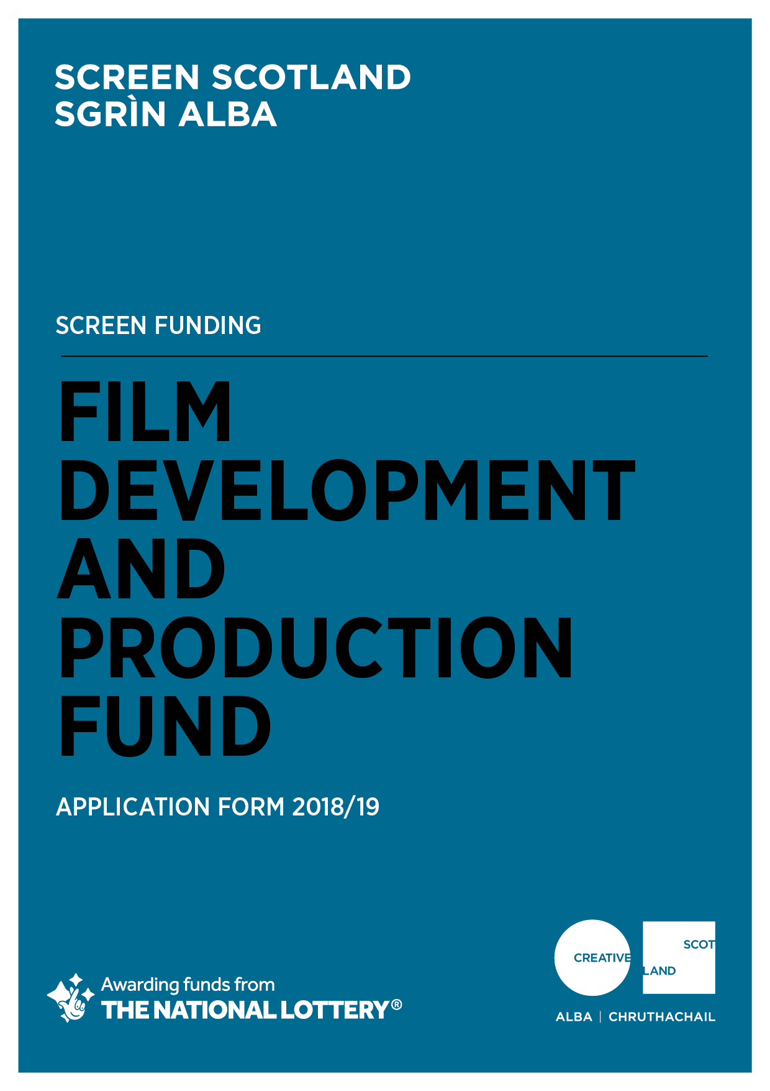

Application Form For
Film Development and Production Fund 2018/19

Advice and Information
Please read the Film Development and Production Fund Guidance before making an application. If you have any general enquiries about the application process, guidelines or application form please contact us
Alternative Formats, Languages and Access Support
We are committed to offering clear and accessible application processes and programmes that are open to everyone. On request this information is available in alternative formats including translations. We offer access support to disabled applicants, tailored to individual requests. Support includes Sign Language Interpreters for meetings and scribing support for dyslexic applicants. Officers can offer advice to new applicants and support them to make an application. The Equalities Team can offer additional one-to-one support to applicants with access requirements. Please note we will accept applications and supporting materials which are written in English, Gaelic or Scots.

If you have any general enquiries about the application process, Guidance or Application Form, please contact our Enquiries Service:
Email: enquiries@creativescotland.com
Telephone: 0345 603 6000* (10am-12pm and 2-4pm, Mon–Fri)

* Please note: Calls to our 0345 number are charged at the same rate as calling national 01 or 02 numbers. Approximate charges are up to 9p per minute from landlines and between 3p - 55p per minute from mobiles. However, calls to this number are also part of inclusive allowances. Please check with your phone line provider for exact charges.

If you are a deaf BSL user, you can access our services with the Contact Scotland-BSL programme. Go to www.contactscotland-bsl.org/public for more information.

In order for us to be able to process your application, you need to complete Sections A-G of this application form.

Please be advised, we will not be able to process your application if you do not answer all the questions.

Section A: Key Information

Please confirm that you have read the Film Development and Production Funding Guidance before completing this application form? (Delete as appropriate) | Yes
 | No
Do you object to receiving funding from the UK National Lottery, for example for religious reasons? (Delete as appropriate) | No
 | Yes
Are you applying as an Individual or an Organisation?  (Delete as appropriate) | Individual
 | Organisation
Please confirm that you have read and understood Creative Scotland’s Funding Privacy Notice and any relevant information sheets before completing this application form?  (Delete as appropriate)  Please note that you must answer this question for your application to proceed | Yes
 | No

Section B: Contact Information
If you are applying as an Individual, only fill in Part 1.
If you are applying as an organisation, please fill in Part 1 and Part 2.
PART 1:
Name of Applicant
Lead Contact Name & Position (if appropriate)
Address
Postcode
Telephone Number
Email Address
Web Address
PART 2:
Trading Name of Organisation
What type of organisation are you? (Please type an X in the box in the right hand column)  (We need this information so we can determine if you are eligible to apply for Screen Funding.  We also need the information so we can monitor our decision making and report to Scottish Government and the National Lottery on the types of organisations we fund). | Arts / Creative Organisation
 | Individual
 | Legally Constituted Partnership
 | Company Limited by Guarantee
 | Company Limited by Shares
 | Sole Trader
 | Consortia, joint organisations or groups of organisations applying together
 | Other (please specify)
Are you a registered company? (Delete as appropriate) |  |  | Yes
 |  |  | No
If you are a registered company, please provide your Registered Office address and Company Number
Are you a registered charity? (Delete as appropriate) |  |  | Yes
 |  |  | No
If you are a registered charity, please provide your Registered Charity Number

Section C: Project Summary

Project/Activity Title
Please detail the activities you intend to undertake with this funding. If you are successful in receiving funding, we may use this information in any publicity we produce about your project or activity (100 words max)
What funding route are you applying to? (Delete as appropriate) | Single Project Development Funding  Film Production Funding
Type of content | Feature Film  Feature Documentary  Animation  Other (please state)
When will the project / activity start?

When do you expect the project / activity to end?
Where will the project / activity take place?  (Please tell us as much information as you can about where your project/activity will take place. We will expect you to fill out at least one of these boxes, but please complete as many as are applicable. | Post Codes:
 | Local Authority areas:
 | Outside Scotland:

What is the total budget of the project / activity? | £
What is the funding you require from Creative Scotland? | £
What percentage is this of the total budget? | %
How much committed co-funding is in place? | £
What percentage is this of the total budget? | %

Please provide a short biography detailing any relevant experience or credits you have had in film and television (please provide details of any completed projects that have received festival screenings, been sold / distributed, received awards):
Number of feature films released theatrically:

Number of network television series broadcast:

Number of television series distributed internationally:

Provide the name(s) and place of residence of the key personnel on this project/activity including postcode.
Name of director(s) and place of residence including postcode (if applicable; you must have a director attached to apply for Production Funding)
Is your project an adaptation of existing material (e.g. novel, play)? (Delete as appropriate) |  | Yes
 |  | No
If yes, indicate which of the following statement applies: | I have secured the option on the existing material.  I have written evidence that I can secure all the rights necessary to produce and exploit the project throughout the world by any means and in all media.  The material is out of copyright.
Section D: Project/Activity Detail
We will use your answers in this section to assess your application against the criteria and guidance as set out in the Screen Funding Guidance.

Creative Statement:
Please tell us about your project’s creative potential and how it demonstrates the ability to be a high-quality work that promotes Scotland’s creativity. Describe what the anticipated benefits and outcomes are, including how it will provide significant opportunities for the creative and professional development of writers, directors, producers and craft and technical talent based in Scotland? (please describe the anticipated benefits and outcomes from the activity to be undertaken with the funding requested)

(500 words max)

Strategic Statement:
Please tell us how your project will be developed and managed. How does it demonstrate the potential to be creatively and/or commercially successful and how will it attract and engage audiences in Scotland, the wider-UK and internationally.

(500 words max)

Section E: Funding/Income Table
This information will be used internally to help inform our work and to report to government and stakeholders.
Type of Funding | Name of Funder / Source of Income | Cash or In-kind | Conditional or Guaranteed or Pending | Amount of Funding / Income | % of Total Project Cost
PUBLIC FUNDING
Creative Scotland
Local Authority
Local Enterprise Companies
Broadcasters
Other Lottery
Own Resources (cash and / or in kind, please specify)
Other
PRIVATE FUNDING
Trusts & Foundations
Companies
Individuals & Fundraising
Other (please specify)
Own Resources (cash and / or in kind, please specify)
EARNED INCOME / OTHER (please add rows as required)
e.g. Box Office
Please specify
Please specify
TOTAL |  |  |  |  | 100%
Section F: Supporting Materials
Please supply the following material | Essential | Please advise if the material is attached to the application or where we can access it
Please provide CV of key personnel (if not covered by short biography at Section C above) | Essential
Excel budget or other industry standard budget  (please indicate all areas of expenditure and detail the budget headings) | Essential
A finance plan for the project, indicating what funding is confirmed. | Essential
If you are applying for Production Funding you should supply a fully developed screenplay. | Essential
If you are applying for Production Funding you should supply a draft Recoupment Schedule. | Essential
For all applicants (individuals and organisations), please provide written evidence of any confirmed partnership funding (in-kind or cash). | Essential
All applicant organisations must provide a copy of founding legal documents (for example Articles of Association, Trust Deeds, or written constitution) | Essential
Sole Traders must provide details of their HMRC Unique Reference Number (URN) | Essential
All applicant organisations must provide their Equalities and Diversity policy, or Equal Opportunities Policy. If you have an Equalities Plan, please submit this also. | Essential

Section G: Statement of Acceptance

PLEASE STATE THE NAME OF THE PERSON WHO HAS COMPLETED THE FORM. THIS PERSON MUST BE AN AUTHORISED SIGNATORY OF THE COMPANY OR ORGANISATION APPLYING OR, IN THE CASE OF AN INDIVIDUAL APPLICANT, BY THE PERSON NAMED IN SECTION B, PART 1, OF THE CONTACT INFORMATION.
I hereby confirm that the information in this application the supporting documents is true and correct and I acknowledge that it is my responsibility to inform you immediately of any changes which could affect the interpretation or context of the application, and I confirm I will undertake to do this.
I acknowledge that the terms and conditions of this application and any other information supplied and discussed regarding this application, the assessment and decision making process, or in connection with this transaction as a whole (“the Confidential Information”) is and shall remain strictly confidential. I confirm that I shall not disclose to any third party or make public the Confidential Information without Creative Scotland’s prior written approval.
I acknowledge that Creative Scotland will endeavour to keep all information provided securely, but as a Public Authority in terms of the Freedom of Information (Scotland) Act 2002, may be required to disclose certain information under the Act. Where I stipulate at the time of providing information to Creative Scotland that I believe the information should be considered exempt from disclosure under that Act, and a request to Creative Scotland is subsequently made for disclosure of same or all of that information, Creative Scotland will endeavour to discuss such disclosure with me prior to making its decision. I do, however, accept and acknowledge that the ultimate decision on disclosure rests solely with Creative Scotland regardless of any prior statements or requests I have issued.
If any of the information I provide is classed as Personal Data under the Data Protection Act 1998; the General Data Protection Regulation (EU) 2016/679 of 27 April 2016 (GDPR); and any legislation supplementary to the GDPR introduced in the United Kingdom (the "Data"), I hereby consent that Creative Scotland may disclose said Data, within and outside of the European Economic Area, for the purposes of producing and submitting any statistical information and reports or as otherwise required by law or by any regulations and other rules to which we are subject.
I confirm that all cash and in-kind contributions from the company or my own personal resources stated in the funding plan section of this application form are correct and that I have the authorisation to allocate the sums stated and I am responsible for ensuring that adequate resources will remain available to meet these requirements. In the event of any changes to the sums indicated I will provide a signed letter of confirmation.
I acknowledge that Creative Scotland is obliged to comply with Money Laundering Regulations 2007 and the Proceeds of Crime Act 2002 and I will, if requested, provide ID verification from any investor or myself, where appropriate, to meet compliance requirements.
I acknowledge that once Creative Scotland have confirmed the Offer of Funding in writing (via email) that Creative Scotland have the right to publicise their Offer of Funding on the Creative Scotland website and through other Creative Scotland information channels. I understand that Creative Scotland’s Offer of Funding does not place Creative Scotland under any obligation to release funds until such time as all contractual negotiations are complete and Creative Scotland’s Conditions Precedent have been met and their Funding Agreements signed off.
I confirm that I will not make any public statements (or allow others to do so on my behalf) regarding Creative Scotland’s Offer of Funding until such time as Creative Scotland has authorised and approved the form and content of any public statement.
I confirm that I have the power to accept the award under the conditions set out in the Creative Scotland Guidance and in this Application Form.
I declare that I have read and understood the Creative Scotland Guidance, this Application Form and the Conditions of Funding of Creative Scotland.

I hereby confirm acceptance of the above Statement of Acceptance and all related documents. (double click and mark as checked)

……………………………………………
Name of Authorised Person

……………………………………………
Position of Authorised Person

……………………………………………
Date

Please now submit your completed application form to: screen@creativescotland.com

Please also complete your Equalities Monitoring Form and email it along with your application form. Please note: the Equalities Monitoring Form is anonymous and will be processed separately from your application.

