Youth Arts Fund
2020-21

Interim Project Update Form (Feb 2021)

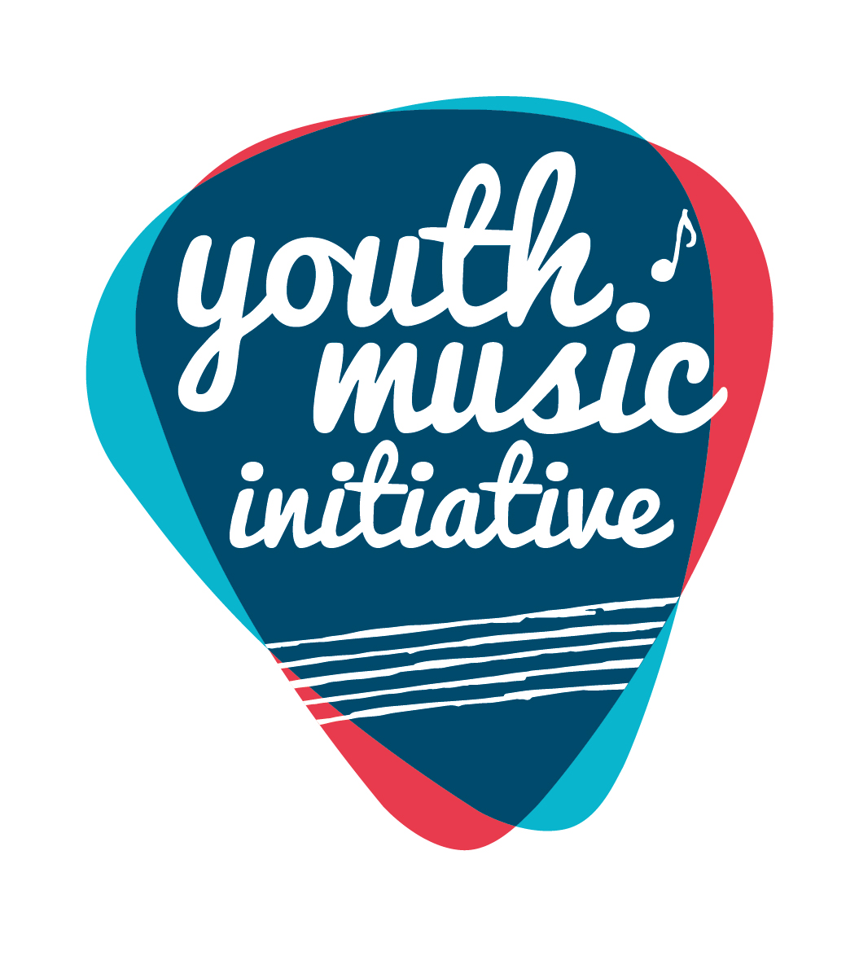

Alternative Formats, Languages and Access Support
Creative Scotland is committed to offering clear and accessible application processes and programmes that are open to everyone. On request this information is available in alternative formats including translations.
We offer access support to disabled applicants, tailored to individual requests. Support includes Sign Language Interpreters for meetings and scribing support for dyslexic applicants. Officers can offer advice to new applicants and support them to make an application. The Equalities Team can offer additional one-to-one support to applicants with access requirements.
Please note we will accept applications and supporting materials which are written in English, Gaelic or Scots.
If you require support, further information or have any general enquiries about the fund and how to apply please contact our Enquiries Service. Our Enquiries Service will be able to advise you or will put you in contact with one of our officers.
You can do this by email, through our website or social media.

Email: enquiries@creativescotland.com
Web: Fill out a form on our website
Twitter: Send us a tweet @creativescots
We aim to respond to all enquiries very promptly. If you want us to call you back, give us your number and we’ll arrange to come back you as soon as possible.
If you are a D/deaf BSL user, you can access our services with the Contact Scotland-BSL programme. Go to: https://contactscotland-bsl.org/deaf-bsl-users/ for more information.

Guidance for completing this form
- All questions require an answer unless otherwise indicated. If a question is not relevant to your project/activity, please indicate ‘n/a’.
- If any of your figures are an estimate, or you are unsure of some information at this stage, please indicate this in your answer.
- The word counts are a guide for the approximate maximum amount you should write. We understand all projects/activities are different, please consider the scope of the work you were funded to deliver and share the appropriate level of information with us to provide an understanding of how it went.
- You can submit further evaluative materials (e.g. links, websites/other documents) if you wish to add additional evidence and context to summarise your project/activity.
If you have any questions in completing this form, please contact us at enquiries@creativescotland.com.

What happens once you’ve submitted this form

Completed forms should be submitted to projectreporting@creativescotland.com.

Once submitted, we will log the report and send it to a Creative Scotland officer for checking approval and sign off. If applicable, once the form is signed off, Creative Scotland will release any interim payments of your grant, as per your funding agreement.
If there are any incomplete or unclear sections, or if we have any further questions, we will be in contact you before approving the form.

Data Protection

Creative Scotland (CS) requires some personal information about you/your organisation to process our funding programmes. If you would like to see a breakdown of the personal information CS requires, why it is required, what CS does with that information and how long CS keeps it, please refer to CS’s Privacy Notice.

CS may share your personal information with third parties to comply with the law and / or for the legitimate interests of CS and / or the third parties concerned. Where the personal information you have provided to CS belongs to other individual(s), please refer to CS’s Privacy Notice. Please ensure you share this Privacy Statement and CS’s Privacy Notice with the respective individual(s).

You have some rights in relation to the personal information that CS holds about you under data protection legislation. Information on how to exercise these rights are contained in CS’s Privacy Notice or you can contact CS’s Data Protection Officer dataprotection@creativescotland.com.

If you have any concerns with how CS has processed your personal information, you should contact CS’s Data Protection Officer in the first instance, as CS would welcome the opportunity to work with you to resolve any complaint. If you are still dissatisfied, you can submit a complaint to the Information Commissioner’s Office.

A: About You

Name of applicant (Organisation)
Lead contact name
Grant reference number (you will find this on the grant offer letter)
Start date for your funded activity (this should be your actual start date not your planned start date) | dd/mm/yyyy
Expected end date for your funded activity | dd/mm/yyyy

B: Overview of Activity

1. Please briefly tell us what activity you have delivered so far. (max 250 words)
2. Please briefly us if any of your activities so far have differed significantly from your application and, if so, why? (max 250 words)

C: Children and Young People
Please note, there is a separate section to tell us about any trainees that were engaged as part of this project; please do not include trainee figures in this section.

3. How many individual children and young people have been involved in the project/activity so far? Please indicate the total number in the left-hand box. Of this total, please indicate how many children and young people in each age bracket were involved so far.

Please do not double count individuals involved in more than one activity.
Total number | 0-4 years | 5-9 years | 10-12 years | 13-17 years | 18-25 years

4. Of the total number of participants so far, broadly what was the gender breakdown? Indicate the total number of participants in each category.

While precise figures are helpful, a broad estimate is fine here if necessary.
Male
Female
Other
Unknown/preferred not to say
5a. Is this project specifically and proactively targeting any of these groups? (tick the appropriate box(es))
Those living in poverty or residing in areas of social and economic deprivation. For more information on the Scottish Index of Multiple Deprivation (SIMD) please visit the Scottish Government website | ☐
Are experiencing or at risk of experiencing harm and neglect. | ☐
Are looked after (as defined by the Children (Scotland) Act 1995) and care leavers (as defined by the Children and Young People (Scotland) Act 2014). For more information please visit the Scottish Government website. | ☐
Are in the early years (0-5) of their life. | ☐
Are from Black and/or Minority Ethnic backgrounds. | ☐
Have a disability and/or additional support needs. | ☐
Are at risk of offending or have previously offended. | ☐
Are young carers (as defined by the Carers (Scotland) Act 2016) and/or young parents | ☐
Are experiencing or at risk of homelessness, or who have been homeless | ☐
Are experiencing mental ill health | ☐
5b. How do you know you are engaging with children and young people from the priority groups you’ve identified above? (max 150 words)

D: Jobs, Trainees and Volunteers

6. How many posts have been funded (or part funded) through the activity so far?
Project Management/co-ordination/Admin staff
Youth work staff or staff in roles supporting children and young people
Freelance artists and creative practitioners
7. Approximately how many days of employment has this funded activity provide for freelance artists and creative practitioners so far?

For sessional work, please estimate number based on a 1-4 hr session equivalent to a half-day, 6-8 hr session equivalent to one day.
8. How many volunteers were involved in supporting this funded activity so far?
9. How many trainees were supported through this activity so far?
(if applicable)

10. How many people so far have benefited from training and continuing professional development linked to your funded activity? (This may include trainees).
11. Tell us about the support you have offered for freelance artists and creative practitioners (including trainees if applicable) as part of your project/activity so far. For example, describe any mentoring, training and workshop activities that have supported freelance artists and creative practitioners and/or tell us about the successes and challenges of implementing your trainee plan. (max 250 words)

E: Partnerships

12. If you worked with any partners/networks/schools to deliver this project/activity so far, provide brief details of their role in and contribution to the project. (add additional rows as necessary)
Partner / network name | Role / contribution | Was this a new or existing relationship prior to applying for this funded activity?  (delete as appropriate)
 |  | New / Existing
 |  | New / Existing
 |  | New / Existing
 |  | New / Existing

F: Income and Expenditure

Please provide the following summary budget information and (if required in your funding agreement) send a certified financial statement using the attached form (See Appendix 1).

13a. Forecast total project expenditure to date | £
13b. Actual total project expenditure to date | £
13c. If there are significant changes (over 10% variation) between actual
and forecast figures, please detail these below and explain how you will manage the changes in budget to complete your project.

Signed
A scan of a written signature is acceptable
Date | dd/mm/yyyy

How to submit your interim project update form

For accounting and audit purposes, this form (and particularly the Certified Income and Expenditure statement in Appendix 1) must be physically signed off by the lead contact for the application as being a true and accurate representation of income and expenditure. A scanned or electronic version of this signature is acceptable.

Please now email your completed form (with scanned signature) to projectreporting@creativescotland.com

When we receive your report, we will log it and send it to a Creative Scotland officer for checking, approval and sign off.

Appendix 1: Certified income and expenditure statement – THIS SHOULD ONLY BE COMPLETED IF YOUR INTERIM PROJECT UPDATE REPORT IS TO RELEASE A PAYMENT, PLEASE CHECK YOUR COTRACT FOR DETAILS.
Name of Applicant (Organisation) |  | Grant reference:
Period financial statement covers: | dd/mm/yyyy – dd/mm/yyyy

Please include all income and expenditure, both cash and in-kind, using the headings given in your application form and in the same order. Where headings include a number of different types of expenditure, you should provide a breakdown showing how the figure has been arrived at. Please provide explanations of any significant variations between budget and actual (greater than 10%) in the Interim Financial form. If you need to use additional pages please include the grant reference number on each page.

Income to date |  |  |  | Expenditure to date
Source | Budget as per application (£) | Actual to date (£) | Projected to end of project (£) | Item |  | Budget as per application (£) |  | Actual to date (£) |  | Projected to end of project (£)
Total |  |  |  | Total
Total surplus / deficit on the project (actual income less actual expenditure) |  |  |  |  |  |  | £

Signed  A scan of a written signature is accepted |  | Date | dd/mm/yyyy
Print name |  | Position  if signing on behalf of an organisation

