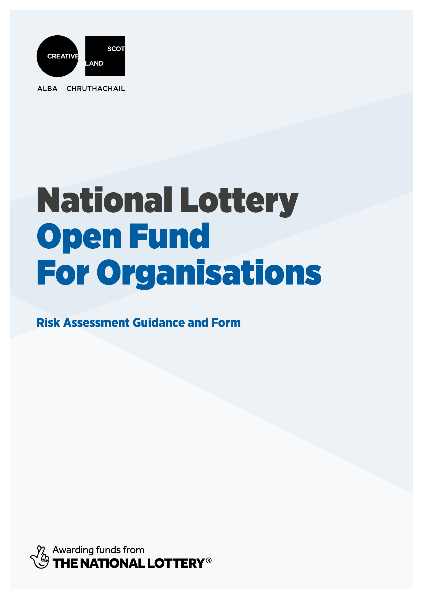
NATIONAL LOTTERY OPEN FUND FOR ORGANISATIONS RISK FORM:
For all applications between £1,000 to £100,000
Please read the guidance below and fill out the risk template at the end of this document. Once completed, please submit alongside your application as one of your supporting documents.
This is a required part of your National Lottery Open Fund for Organisations application.
1 GUIDANCE
1.a. What is risk management?
Risk management means identifying, assessing and taking action to control threats in business or other activity.
1.b. Why do we ask you to assess risk?
We want to understand how you are addressing the full range of risks that could affect your ability to deliver the activity that you’re applying to the fund to support. This is not a paper exercise, and we will make an assessment of the risk management plans provided.
All activity involves risk. Thinking about risk helps you take action(s) to manage threats to the success of your activity and, in many cases, minimise risk to a significant degree Risk management should inform the way you think about the activity that you plan to do. Risks to your activity are not just about health and safety – there may be a range of unpredictable elements that could affect the successful delivery of your activity.
Risk management forms part of governance and we appreciate that you may have your own risk management framework for your overall activities. Please complete the risk template for this activity specifically to allow us to assess your plans effectively. If you want to tell us anything else about your approach to risk – for example if you have a board-owned risk appetite – please include this in the form under management and governance.
If you do not think about risks from the start of the planning of the activity, you may encounter issues that affect you, your project or other people. These issues could be very serious.

1.c. How should I manage risk?
There are three steps in managing risk:
- Identify. This means thinking through your project or activity to establish potential threats to its successful delivery.
- Assess. This means thinking about the severity of each risk, and how probable it is that the risk might actually occur.
- Control. This means devising a plan to minimise the likelihood of the risk occurring, and/or to manage the severity of the effects if the risk occurs.
1.d. How to identify risk
A good way to start identifying risks is to ask yourself, ‘what's the worst that could happen?’. So write down all the things that would be an issue for you in delivering you activity – these might be as simple as someone working on the project getting sick, or bad weather affecting an outdoor event; or they could be more complex risks, such as a key piece of funding not being secured. Don’t try to assess these risks as you think of them. Just note them down and assess them in the next stage.
1.e. How to assess risk: traffic lights
When you have identified risks to your activity, you should use the following table to establish how severe the risk is:
Severity of risk  (how bad the effects could be if risk occurred) | Probability of risk  (how likely it is that it will occur)
Not severe  (no danger to people and/or will not stop activity) | Unlikely
Relatively severe  (potential danger to people and/or activity) | Relatively likely
Severe  (high risk to people and/or activity) | Highly likely

You should then assign a traffic light to the risk as follows:
RED | Severe/highly likely  OR Severe/relatively likely | RED is critical. Red risks are not tolerable. Action must be taken to address these risks.
AMBER | Severe/unlikely  OR Relatively severe/highly likely  OR Relatively severe/relatively likely  OR Not severe/highly likely | AMBER risks must be addressed but may remain AMBER. You may decide that this is tolerable.
GREEN | Relatively severe risk/unlikely  OR Not severe risk/relatively likely  OR Not severe risk/highly likely | GREEN risks may be automatically tolerated but best practice suggests you should consider action to address if possible.

1.f. How to control risk
You should identify the actions you will take to reduce the severity of the risk AND/OR the probability of the risk. When you have done so, you should recalculate the traffic light using the system above. Some risks will remain the same colour. NB. If any risk remains RED, Creative Scotland is likely to consider your project unfundable due to critical risk. You should consider replanning your project with significant alterations to address the risk before you apply.
1.g. How this might work in reality
Example 1: A visual artist considers risk relating to a public installation
- Identify. My project is dependent on access to a public space to manage an installation. Injury to a member of the public is a risk.
- Assess. This risk is severe as it could relate to potentially serious injury. I might be liable in law and there could be a severe financial implication. The probability of the risk occurring is relatively likely if I take no action. Severe risk, relatively likely = RED.
- Control. I have taken out appropriate insurance to reduce the financial risk to me of any incident, but any risk involving injury is still severe. I can reduce the probability of the risk by ensuring I work with appropriate authorities and take appropriate safety measures. This reduces risk rating to Severe risk, unlikely = AMBER. I consider this a tolerable risk in the context.
Example 2: An organisation considers risk relating to ticket sales
- Identify. 50% of income in our project budget is raised through ticket sales. Failure to sell enough tickets is therefore a risk.
- Assess. This risk is severe. Our costs are upfront and so we have no way to recoup these in the event we have an issue relating to ticket sales. If we fail to raise this income, we may face financial difficulties. The probability of the risk occurring is relatively likely unless we take specific action to address it. Severe risk, relatively likely = RED.
- Control. We have reduced the risk to Relatively severe by revising our budget to include ticket sales at a level we consider realistic and achievable. We have ensured our costs are as efficient as possible and we have included a contingency. We have reduced the probability of this risk by creating a strong marketing plan working with appropriate partners. Relatively severe risk, unlikely = GREEN.
1.h. COVID
Since March 2020, COVID has been an issue for organisations to manage, rather than a risk. However, with most formal COVID restrictions no longer in place, it can now be considered a risk for most organisational programmes or projects. Future outbreaks or varients have the potential to affect projects through, for example, people involved in the project becoming infected and no longer being able to take part; reduced audiences or cancelled events due to local infections; or national, regional or local restrictions on public activity. Your project may also be disproportionately affected depending on your activity – for example if you are planning international activity, or if you are working with people who are clinically vulnerable. Hence COVID should be considered by all applicants within the risk assessment below.
2. Overall Risk Management Template
IDENTIFY | ASSESS |  | CONTROL
Risk identified | Severity and probability (explain) | Rating (delete as appropriate) | Control actions planned | New severity/probability | New rating (delete as appropriate)
 |  | RED  AMBER  GREEN |  |  | RED  AMBER  GREEN
 |  | RED  AMBER  GREEN |  |  | RED  AMBER  GREEN
 |  | RED  AMBER  GREEN |  |  | RED  AMBER  GREEN
 |  | RED  AMBER  GREEN |  |  | RED  AMBER  GREEN
 |  | RED  AMBER  GREEN |  |  | RED  AMBER  GREEN
 |  | RED  AMBER  GREEN |  |  | RED  AMBER  GREEN
 |  | RED  AMBER  GREEN |  |  | RED  AMBER  GREEN
 |  | RED  AMBER  GREEN |  |  | RED  AMBER  GREEN
(continue on additional sheets as required)

