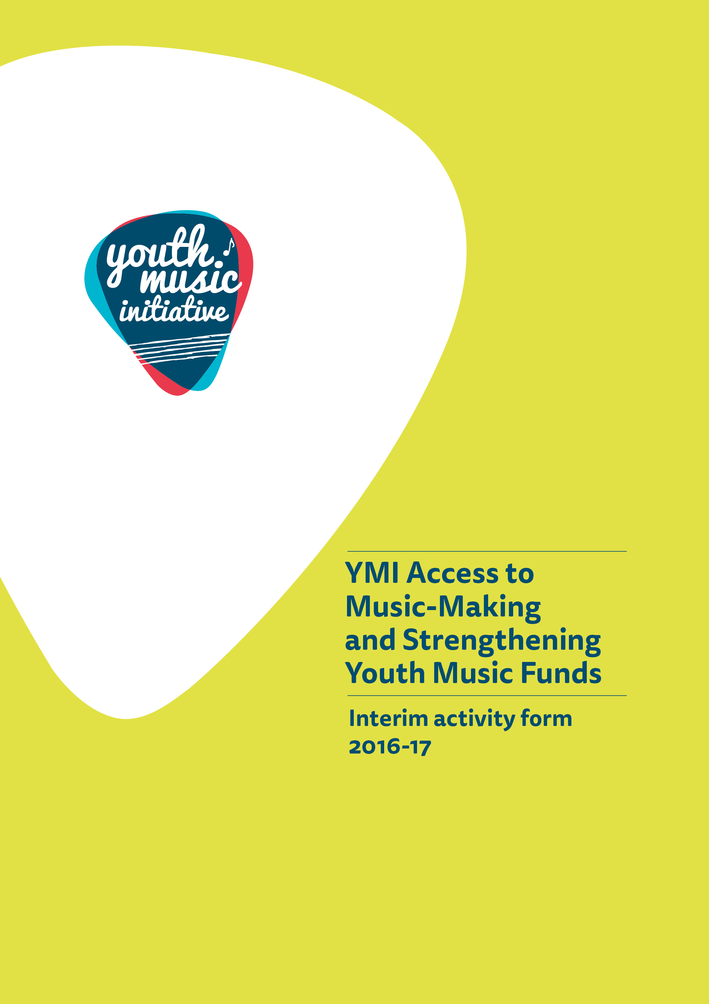
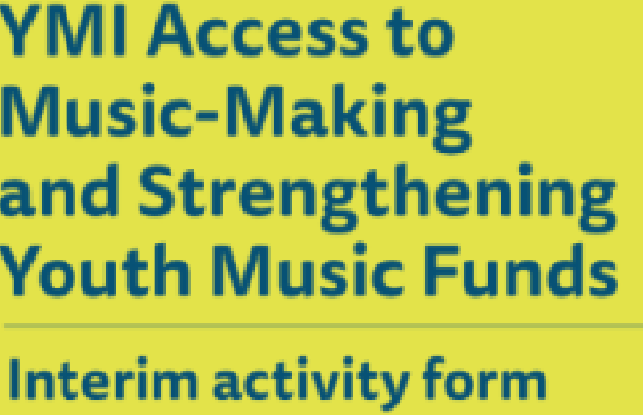
Update Form 2018

Update Form 2018
Access to Music-Making and Strengthening
Youth Music Funds

About You

Name of applicant (Organisation)
Lead contact name
Grant reference number (you will find this on the grant offer letter)
Start date for YMI funded activity (this should be your actual start date not your planned start date)
End date for YMI funded activity

Activity

1. Please briefly (in a maximum of 250 words) tell us what activity you have delivered so far.
2. Please briefly (in a maximum of 250 words) tell us if any of your activities so far have differed significantly from your application and, if so, why?

Participants

3. How many individual young people have been involved in YMI funded activity so far?
Please do not double count individuals involved in more than one activity.
4. What level of involvement has each individual young person had?
Please provide an estimate if required. We understand that this may not match the figure at Q3 if young people were involved in multiple activities.
LEVEL | DEFINITION |  | NUMBER OF YOUNG PEOPLE
One-off activity | A one-off taster activity, an introduction to music
Ongoing drop-in activity | Flexible, drop-in activity with no need to book in advance and no commitment to participate over time
Ongoing planned involvement | A series of planned opportunities, offered over a period of time, such as a course or a series of workshops which participants are expected to take part in for the full duration.
Other (please specify)
Unknown | Level of involvement not known
Comments:

Profile of Participants

5. Of the total number of participants so far, what was the gender breakdown? While precise figures are helpful, a broad estimate is fine if necessary.
Male
Female
Other (for example transgender)
Unknown/preferred not to say
- Is your project specifically and proactively targeting any of the groups below? These should be the priority groups that you identified your project would proactively target in your application form.
Looked after children and young people (as defined by the Children (Scotland) Act 1995) and care leavers (as defined by the Children and Young People (Scotland) Act 2014) | ☐
Young people resident in areas of social and economic deprivation ranking high in the Scottish Index of Multiple Deprivation (SIMD) | ☐
Young people from minority ethnic backgrounds | ☐
Young people who are disabled and/or have additional support needs | ☐
Young people who are at risk of offending or who have previously offended | ☐
Young carers or young parents | ☐
Children in the early years (0 to 5 years) of their life | ☐
- How do you know you are reaching your target groups? For example, are young people being referred from organisations working with the target groups?

Jobs, Trainees and Volunteers

- How many posts have so far been funded (or part funded) through YMI?
Number of posts
Permanent – full time
Permanent – part time
Temporary – full time
Temporary – part time
- How many volunteers and trainees have been involved in supporting YMI activity so far?
Volunteers
Trainees
*Please refer to the application criteria within the Application Guidelines 2016-17. Not required for applications for less than £5,000
- How many people have benefited so far from training and continuing professional development linked to your YMI activity?
*If not applicable please leave blank

Outcomes
We are very keen to know what difference your YMI work is making. This is a very important part of this form.

- Think back to your application for YMI funding, where you were required to choose the outcomes you aimed to bring about for each of your projects.

Please answer the following question for each of these outcomes.

What evidence, if any, do you have about progress towards your intended outcomes so far?
This includes evidence gathered from young people, deliverers, partner organisations and other relevant stakeholders. It could include surveys, discussions, emails, videos, case studies and observational evidence.
- Do you feel that you need any more support to think about and evidence outcomes for your final project form? If so, what kind of support do you need?

Signed: | Date:

How to submit your Update Form

Please either attach your supporting evidence (photographs, videos, audio files) to your email to us, or let us know how you would prefer to share this type of information (e.g. through Dropbox or an online link to existing information).

This form must be physically signed off by the lead contact for the application as being a true and accurate representation of activity. A scanned or electronic version of this signature is acceptable.

Please now email your completed form (with scanned signature) to projectreporting@creativescotland.com

When we receive your report, we will log it and send it to your lead officer within the YMI team.

Appendix One: Certified income and expenditure statement – THIS SHOULD ONLY BE COMPLETED IF YOUR REPORT IS TO RELEASE A PAYMENT, PLEASE CHECK YOUR COTRACT FOR DETAILS.
Name of Applicant (Organisation): |  | Grant reference:
Period financial statement covers:

Please include all income and expenditure, both cash and in-kind, using the headings given in your application form and in the same order. Where headings include a number of different types of expenditure, you should provide a breakdown showing how the figure has been arrived at. Please provide explanations of any significant variations between budget and actual (greater than 10%) in the Interim Financial form. If you need to use additional pages please include the grant reference number on each page.

Income to date |  |  |  |  |  | Expenditure to date
Source | Budget as per application (£) | Actual to date (£) | Projected to end of project (£) |  |  | Item | Budget as per application (£) | Actual to date (£) | Projected to end of project (£)
Total |  |  |  |  |  | Total
 |  |  |  | Surplus/ deficit to date (ie. income to date less expenditure to date): £

Signed: Date:
Printed name: Position (if signing on behalf on an organisation):
Important information

Openness and accountability
Information supplied by you will be held in manual files. It will then be summarised and details transferred to a computer-based grants management system. Reports from the information you supply and from any comments made by external assessors and staff members are likely to be held on both manual and computer-based systems. The information you supply will be made available to those assessing any other grant applications you make.
Data protection
Data held on our grants management system is used for statistical and accounting purposes. We view your signature on your application form as acceptance of the use of your data outlined above.

For more information go to http://www.gov.scot/Topics/People/Young-People/protecting/lac
http://www.gov.scot/Topics/People/Young-People/protecting/lac/careleavers
For more information go to http://www.gov.scot/Topics/Statistics/SIMD

