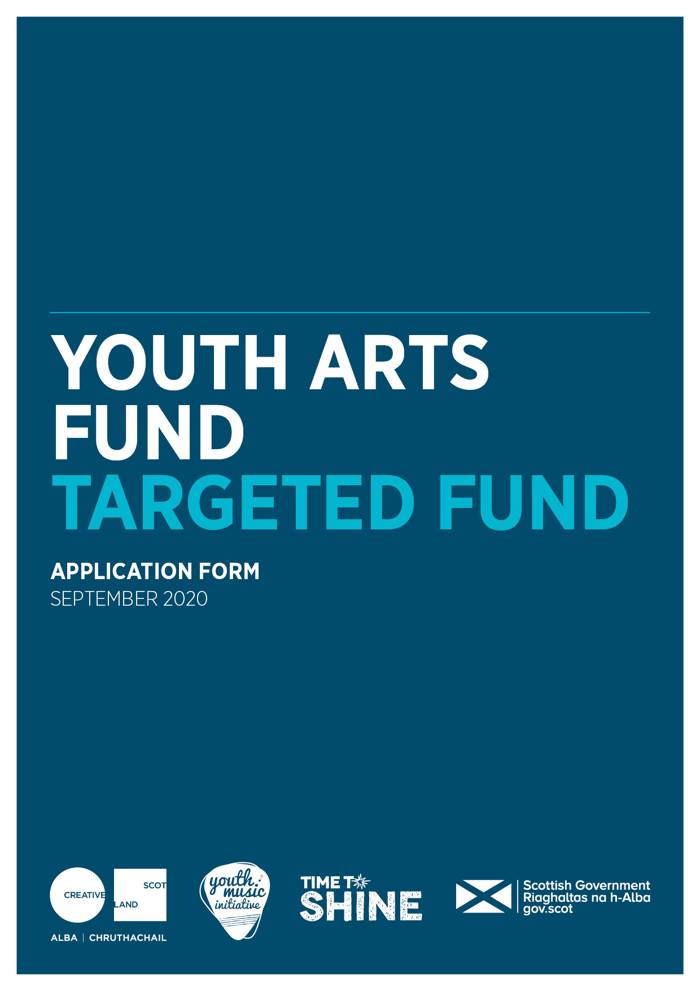
Advice and Information
Please read the Guidance for the Youth Arts Targeted Fund before you complete this form.
Please Note: In order to apply for this fund you must be one of the 20 targeted organisations who have been approached by Creative Scotland, or a partnership made up of 2 or more of these organisations.

Alternative Formats, Languages and Access Support
Creative Scotland is committed to offering clear and accessible application processes and programmes that are open to everyone. On request this information is available in alternative formats including translations.
We offer access support to disabled applicants, tailored to individual requests. Support includes Sign Language Interpreters for meetings and scribing support for dyslexic applicants. Officers can offer advice to new applicants and support them to make an application. The Equalities Team can offer additional one-to-one support to applicants with access requirements.
Please note we will accept applications and supporting materials which are written in English, Gaelic or Scots.
If you require support, further information or have any general enquiries about the fund and how to apply please contact our Enquiries Service. Our Enquiries Service will be able to advise you or will put you in contact with one of our officers.
You can do this by email, through our website or social media.
Email: enquiries@creativescotland.com
Web: Fill out a form on our website
Twitter: Send us a tweet @creativescots
We aim to respond to all enquiries very promptly. If you want us to call you back, give us your number and we’ll arrange to come back you as soon as possible.
If you are a D / deaf BSL user, you can access our services with the Contact Scotland-BSL programme. Go to: https://contactscotland-bsl.org/deaf-bsl-users/ for more information.

In order for us to be able to process your application, you need to complete ALL sections of this application. Please be advised, your application will be considered incomplete and will not be assessed if you do not provide an answer for each of the questions. If you consider that you have answered a question elsewhere in your application, please clearly tell us where.
Section A: Key Information
Please confirm that you have read the Guidance for Youth Arts Targeted Fund before completing this application form? (Delete as appropriate)  Please note that you must answer this question for your application to proceed | Yes
 | No

Are you applying as part of a consortium application? If yes, please list the name of the other targeted organisations below. | Yes
 | No

Please confirm that you have read and understood Creative Scotland’s Funding Privacy Notice before completing this application form. | Yes
 | No
Please confirm you have read and understood Creative Scotland’s Grant in Aid Funding Terms and Conditions | Yes
 | No

Section B: Contact Details
Please note that all correspondence will be made by email with the named lead contact only. Please ensure this information is correct and the lead contact is fully aware of the details in the application.
Name of Organisation
Lead Contact Name and Position (if appropriate)
Address
Postcode
Telephone Number
Email Address
Web Address
Are you a registered company? (Delete as appropriate) |  | Yes
 |  | No
If you are a registered company, please provide your Registered Office address and Company Number
Are you a registered charity? (Delete as appropriate) |  | Yes
 |  | No
If you are a registered charity, please provide your Registration Number
Trading Name of Organisation
Full Legal Name of Organisation (if different from above)
Which of these legal types of organisation are you? (You should only choose one. Please type an X in the relevant box in the right hand column)  We need the information so we can monitor our decision making and report to Scottish Government and the UK National Lottery on the types of organisations we fund. | Company Limited by Guarantee
 | Scottish Charitable Incorporated Organisation (SCIO)
 | Community Interest Company (CIC)
 | Local Authority
 | Cultural and Leisure Trust
 | Public Sector Agency
 | Trust or Foundation
 | Other (please list below)

Section C: Proposal Summary
Proposal Title | Youth Arts Targeted Fund
Please summarise your proposal. If you are successful in receiving funding, we may use this information in any publicity we produce about your proposal (200 words maximum)
How much funding are you applying to Creative Scotland for? | £
When do you expect the project to start / end? | Start
 | End
Where will your activity take place?  Please tell us as much information as you can about where your activity will take place. We will expect you to fill out at least one of these boxes, but please complete as many as are applicable. | Post Codes:
 | Local Authority areas:

What art form(s) or specialist area(s) would you use to categorise your application? Please type an X in the box to the right of the artform/area. If you are selecting more than one, please type XX in the box to the right of your main artform/area.

We need this information so we can ensure that your application is assessed by a Creative Scotland Officer with relevant expertise.

We also need the information so we can monitor our decision making and report to the Scottish Government and the National Lottery on the range and type of activities we fund.
Multi-art form |  | Creative Learning
Crafts |  | Children and Young People
Dance |  | Place and Communities
Design |  | Traditional Arts
Digital |  | Gaelic Language
Literature |  | Gaelic Culture
Music |  | Scots
Theatre |  | Arts and Health/Wellbeing
Visual Arts |  | Equalities, Diversity and Inclusion
Other (please specify)

Section D: Proposal Detail
1. Programme of activity

In this section please provide an overview of your programme of activity that will be delivered, including timelines, key dates and activity plans (if possible) outlining how it will address the guiding principles, priorities and criteria of the fund.

Participants
Please estimate how many children and young people there will be in each of the following age brackets:

0-4 | 5-9 | 10-12 | 13-17 | 18-25

Please tell us how your project is addressing inequality, by proactively targeting any of the following groups. Please refer to the priorities in the guidelines. (You can tick more than one option here)
Yes
(Please tick)
Those living in poverty or residing in areas of social and economic deprivation. For more information on the Scottish Index of Multiple Deprivation (SIMD) please visit the Scottish Government website | ☐
Are experiencing or at risk of experiencing harm and neglect. | ☐
Are looked after (as defined by the Children (Scotland) Act 1995) and care leavers (as defined by the Children and Young People (Scotland) Act 2014). For more information please visit the Scottish Government website. | ☐
Are in the early years (0-5) of their life. | ☐
Are from Black and/or Minority Ethnic backgrounds . | ☐
Have a disability and/or additional support needs. | ☐
Are at risk of offending or have previously offended. | ☐
Are young carers (as defined by the Carers (Scotland) Act 2016) and/or young parents | ☐
Are experiencing or at risk of homelessness, or who have been homeless | ☐
Are experiencing mental ill health | ☐
Please describe how you will ensure barriers to participation whether physical, socio-economic, personal or peer related will be removed for children and young people from the priority groups selected.

Please describe the specific actions and/or partnerships you propose to recruit and support participants from your target audience to take part in your project.

Please describe how children and young people will have opportunities to influence, lead and have their voices heard in all design and delivery.

Section E: Project Management
Please describe how the project will be managed, including staff roles and responsibilities, and details of project partners and their roles.

If you are submitting an application as a consortium, please provide a detailed outline of roles and responsibilities for each targeted organisation along with letters of support.

Please indicate how many roles will be supported through the project outlining if they will be full time or part time.

Project Management/Co-ordination/Admin staff
Freelance artists and creative practitioners
Youth work staff or staff in roles supporting children and young people
Trainees
Volunteers

Please describe how you will support the development of staff/tutors working on the project.

Please describe how you will provide opportunities for emerging practitioners to gain practical experience and develop skills through the project. Please submit a separate training plan.

Please describe how you will monitor activity and evaluate your project including the methods and indicators you will use.

Section F: Budgets and Funding

What is the total budget of the project / activity? | £
What is the funding you require from Creative Scotland? | £
If you are proposing to include any additional funding please outline the total amount and outline if this funding is either guaranteed or pending? | £
 | Guaranteed | Pending

Please submit a separate one-page budget, using the template provided.

Please note budget figures should be rounded up to the nearest £.

Have you completed the separate budget using the template provided? (Delete as appropriate) | Yes/No

Type of Funding | Name of Funder / Source of Income | Cash or In-kind | Conditional or Guaranteed or Pending | Amount of Funding / Income | % of Total Project Cost
PUBLIC FUNDING
Creative Scotland
Local Authority
Own Resources
Other
PRIVATE FUNDING
Trusts & Foundations
Companies
Individuals & Fundraising
Other (please specify)
Own Resources
EARNED INCOME / OTHER (please add rows as required)
e.g. Box Office
TOTAL |  |  |  |  | 100%

Section G: Essential and supporting material

Please detail all the supporting material you have submitted and note where Creative Scotland can access this material. For more information on how you can submit your supporting material, and our preferred formats, see www.creativescotland.com/preferred-formats.

Please refer to the Youth Arts Targeted Fund for guidance on what supporting material is required.

Please detail the supporting material submitted | Please advise if the material has been attached to the application or where we can access it
Copy of your constitutional documents (or, Unique Tax Reference Number (URN) if you are applying as a sole trader) and Equal Opportunities Policy (Essential if applying to Creative Scotland for the first time)
One page budget on the template provided (Essential)
A risk assessment on the template provided (Essential)
A copy of your organisation’s Child Protection Policy (Essential)
CV or detailed biography of project staff, artist, professionals, indicating experience relevant to their role in this project (Essential)
A structured training plan for emerging practitioners (Essential)
Letters or emails from partners outlining support and their involvement in the project (Optional)

NB: Please ensure that you comply with data protection law if providing CS with personal information contained in Remits/Job Descriptions and CVs and that you share CS’s Funding Privacy Notice with the respective individual(s).

Section H: Statement of Acceptance

Your statement (Please mark with an X in the relevant boxes) | X
I confirm that I have read and understood the guidelines which accompany this form.
I confirm that I have read and understood the Funding Privacy Notice
I confirm that I have read and understood the Terms and Conditions
I confirm that all the information in this application, and any documents provided to support it, is true and correct.
I confirm that I will inform you immediately if anything changes which could affect this application in any way.
I note that any grant awarded will be subject to standard and specific conditions and I confirm that I have the power to accept the grant under any conditions you set and to repay the grant if we do not meet them.
I hereby confirm that all Project Staff / Trainees (if applicable) engaged in any of the projects outlined will be members of the Protection of Vulnerable Groups Scheme administered by Disclosure Scotland before the project begins.
Please check this box to receive regular email updates from the Youth Music Initiative and Creative Scotland.

PLEASE STATE THE NAME OF THE PERSON WHO HAS COMPLETED THE FORM. THIS PERSON MUST BE AN AUTHORISED SIGNATORY OF THE COMPANY OR ORGANISATION APPLYING OR, IN THE CASE OF AN INDIVIDUAL APPLICANT, BY THE PERSON NAMED IN SECTION B, PART 1, OF THE CONTACT DETAILS.
I hereby confirm that the information in this application submission including the supporting documents is true and correct and I acknowledge that it is my responsibility to inform you immediately of any changes which could affect the interpretation or context of the application, and I confirm I will undertake to do this.
I acknowledge that the terms and conditions of this application and any other information supplied and discussed regarding this application, the assessment and decision making process, or in connection with this transaction as a whole (“the Confidential Information”) is and shall remain strictly confidential. I confirm that I shall not disclose to any third party or make public the Confidential Information without Creative Scotland’s prior written approval.
I acknowledge that Creative Scotland will endeavour to keep all information provided securely, but as a Public Authority in terms of the Freedom of Information (Scotland) Act 2002, may be required to disclose certain information under the Act. Where I stipulate at the time of providing information to Creative Scotland that I believe the information should be considered exempt from disclosure under that Act, and a request to Creative Scotland is subsequently made for disclosure of same or all of that information, Creative Scotland will endeavour to discuss such disclosure with me prior to making its decision. I do, however, accept and acknowledge that the ultimate decision on disclosure rests solely with Creative Scotland regardless of any prior statements or requests I have issued.
If any of the information I provide is classed as Personal Data under the Data Protection Act 1998; the General Data Protection Regulation (EU) 2016/679 of 27 April 2016 (GDPR); and any legislation supplementary to the GDPR introduced in the United Kingdom (the "Data"), I hereby consent that Creative Scotland may disclose said Data, within and outside of the European Economic Area, for the purposes of producing and submitting any statistical information and reports or as otherwise required by law or by any regulations and other rules to which we are subject.
I confirm that all cash and in-kind contributions from the company or my own personal resources stated in the funding plan section of this application form are correct and that I have the authorisation to allocate the sums stated and I am responsible for ensuring that adequate resources will remain available to meet these requirements. In the event of any changes to the sums indicated I will provide a signed letter of confirmation.
I acknowledge that Creative Scotland is obliged to comply with Money Laundering Regulations 2007 and the Proceeds of Crime Act 2002 and I will, if requested, provide ID verification from any investor or myself, where appropriate, to meet compliance requirements.
I acknowledge that once Creative Scotland have confirmed the Offer of Funding in writing (via email) that Creative Scotland have the right to publicise their Offer of Funding on the Creative Scotland website and through other Creative Scotland information channels. I understand that Creative Scotland’s Offer of Funding does not place Creative Scotland under any obligation to release funds until such time as all contractual negotiations are complete and Creative Scotland’s Conditions Precedent have been met and their Funding Agreements signed off.
I confirm that I will not make any public statements (or allow others to do so on my behalf) regarding Creative Scotland’s Offer of Funding until such time as Creative Scotland has authorised and approved the form and content of any public statement.
I confirm that I have the power to accept the award under the conditions set out in the Creative Scotland Guidelines and in this Application Form.
I declare that I have read and understood the Creative Scotland Guidelines, Funding Privacy Notice, this Application Form and the Conditions of Funding of Creative Scotland.

……………………………………………
Name of Authorised Person

……………………………………………
Position of Authorised Person

……………………………………………
Date
Please submit your completed application form to: youthartsfund@creativescotland.com

Please now complete your Equalities Monitoring Form and email it along with your application form. Please note: the Equalities Monitoring Form is anonymous and will be processed separately from your application.

