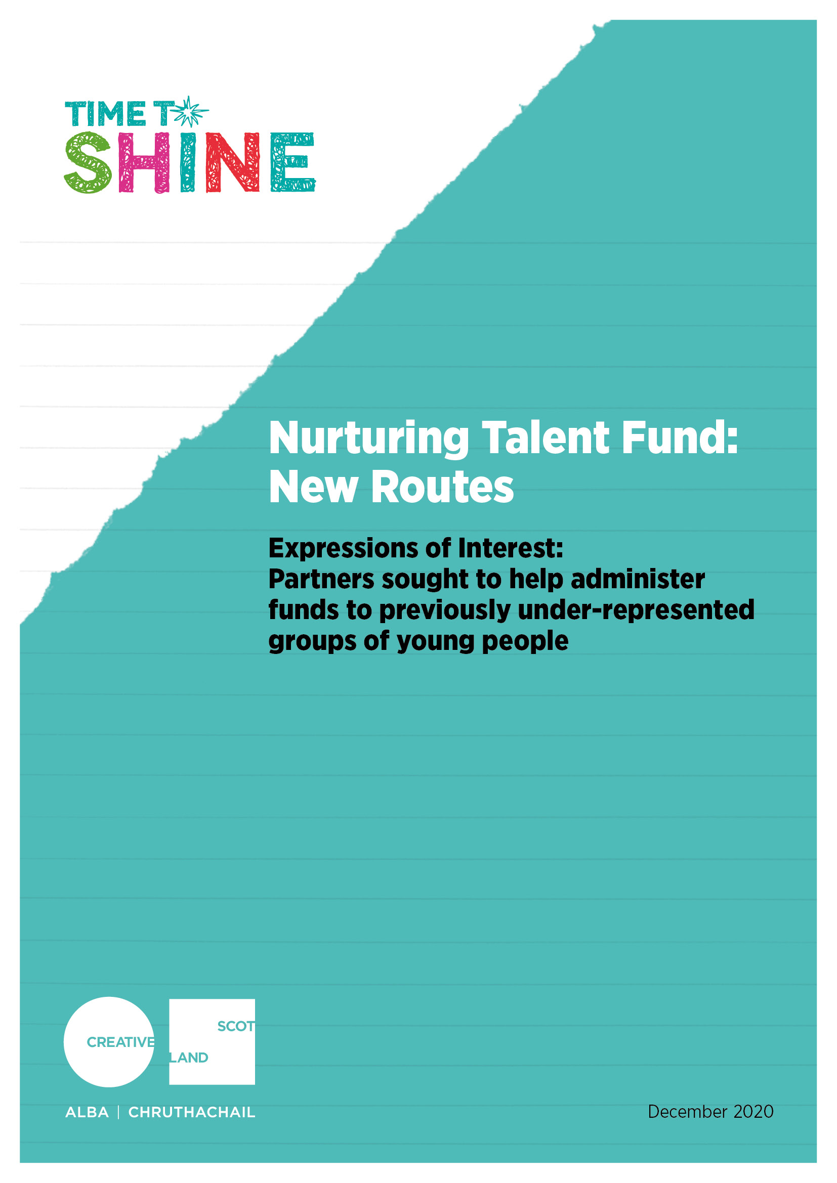
Background to Nurturing Talent Fund
The Nurturing Talent Fund (NTF) was established in 2014 as part of Time to Shine, the national Youth Arts Strategy. The Fund was established and managed by the National Youth Arts Advisory Group (NYAAG) - a group of young people aged 14-23 from across Scotland who advocate for youth arts in Scotland. Awards of up to £1,000 were open to applications from young people aged 11-25 for their own creative ideas and ambitions. To date, the NTF has distributed nearly £135,000 directly to young people across 251 projects. A list of recent awards can be found here: https://youngscot.net/news-database/young-pepole-support-scotlands-young-creative-stars
Since 2014, Young Scot has supported NYAAG to administer the Nurturing Talent Fund, and the fund remains open to applications in 2020/21 – there are three remaining deadlines : 6 December 2020; 14 March 2021; 6 June 2021.
Alongside this, and as a direct result of new funding made available to support the Nurturing Talent Fund we are looking for three partner organisations to help us deliver three new targeted, fixed-term initiatives that will inform the ongoing development of Nurturing Talent Fund. These approaches will:
- Provide opportunities for a wider demographic of children and young people to participate in decision making processes
- Address barriers to accessing direct support for children and young people to develop their own self-directed activity and ambitions
Nurturing Talent Fund: New Routes
In August 2020, the Scottish Government announced that the culture and heritage sectors in Scotland were to benefit from a £59m funding package to protect jobs and help the industry weather the effects of the coronavirus (COVID-19) pandemic.

As part of this announcement £3m was allocated to support youth arts and ensure creative opportunities for children and young people continue to exist across Scotland despite the COVID-19 pandemic, including a £50k boost to the Nurturing Talent Fund to provide opportunities to young, emerging artists who are entering a challenging funding environment.

Following a review of awards to date, we are interested in testing out approaches to nurturing talent for some of the young people who are currently under-represented in Nurturing Talent Fund awards to date. Specifically we are looking for partners who can help us reach:
- Young artists from care experienced backgrounds
- Young artists from rural communities and local authorities we get fewer applications from, specifically: Angus, West Dunbartonshire, Inverclyde, North Ayrshire, and Fife.
- Young disabled artists, or young people who need additional support.

We are looking to work with three organisations who can each manage a Nurturing Talent Fund that explores how to work with young people from the priority groups above to deliver:
- Direct support for young people to undertake their own self-directed creative or artistic project or activity
- A youth-led decision-making process for applications and awards.
Organisations do not have to be arts-based, but they should be able to demonstrate a commitment to supporting children and young people to access the arts and who can demonstrate:
- how they can reach children and young people who are not currently accessing formal arts opportunities through their networks
- how they will manage a funding process that supports activity across artforms
- how their proposed approach will be open to applications or proposals directly from children or young people

Proposals from organisations with specific geographic areas of focus are welcome, provided they can demonstrate their reach with one of the priority groups.

A total of £16,600 is available per organisation to deliver between February and June 2021.

Timelines:
This call is live from Thursday 3rd December 2020.
The deadline for submissions of expressions of interest is 5pm on Friday 8 January 2021.
We anticipate confirming awards to external delivery partners w/c 25 January 2021.
Selected partners should aim to deliver the funding between February and December 2021.

How to apply:
If you are interested, please use the form below to submit an Expression of Interest, providing details of your organisation's status and ability to deliver the funding to the targeted groups. If you would like to discuss this opportunity in more detail please contact: sarah.mcadam@creativescotland.com.

Expressions of Interest must be submitted to sarah.mcadam@creativescotland.com no later than 5pm on Friday 8 January 2021.

What happens next:
Once we receive all the expressions of interest, we will map the provision offered by our potential partners and this will inform next steps in the process.

As part of this, we will speak to all applicants w/c 11 January 2021 – so please ensure that your main contact is available during this period and/or that an alternative contact is provided in the event of staff leave or similar.

PLEASE COMPLETE THE FOLLOWING EXPRESSION OF INTEREST FORM AND SEND TO sarah.mcadam@creativescotland.com BY NO LATER THAN 5PM ON 8 JANUARY 2021
Name of Applicant
Lead Contact Name and Position (if appropriate)
Address
Postcode
Email address of Main Contact
Telephone number of Main Contact
Website
Legal Type of Organisation | Company Limited by Guarantee
 | Consortia, joint organisations or groups of organisations applying together
 | Community Interest Company
 | Scottish Charitable Incorporated Organisations (SCIO)
 | Local Authority
 | Culture Leisure Trust
 | Public Sector Agency
 | Trust or Foundation
Registered Charity Number (if applicable)
Which of the target groups are you seeking to address with the funding? (250 words)
In what ways are you currently working or have experience in working with the targeted group? (250 words)
Provide details of how the fund might work and how you will target this group. (You may attach as a supplementary document)
(250 words)
How would you monitor equality and diversity and how you would report outcomes to us? (250 words)
How do you plan on involving young people as part of the decision-making process? (250 words)

