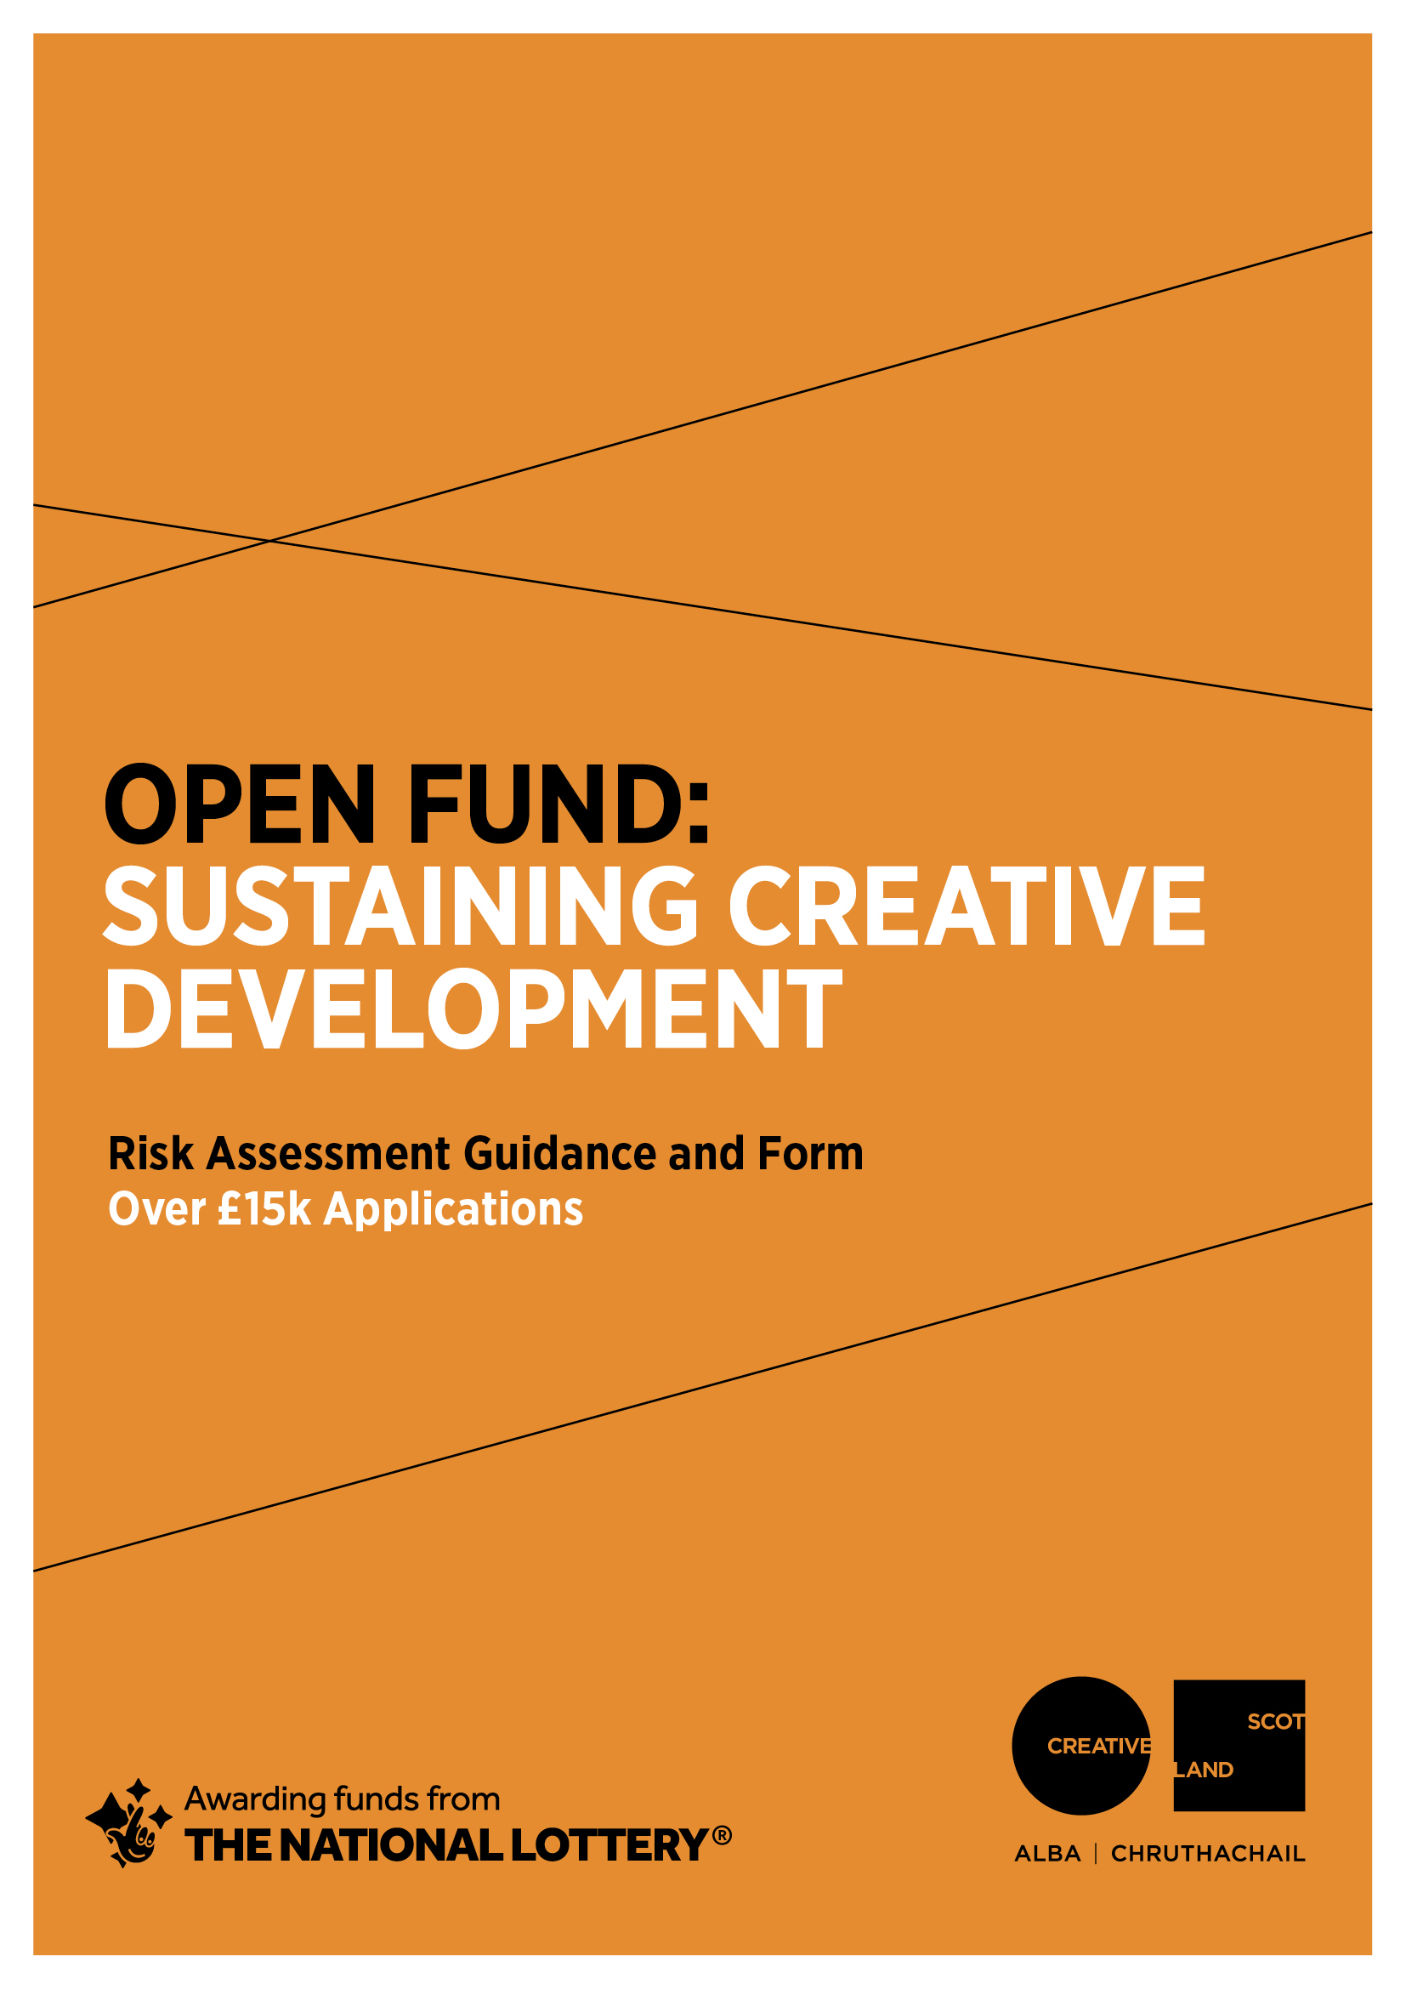

RISK FORMS: Applications for £15,001 to £100,000
Please read the guidance below and fill out the two risk templates at the end of this document. This is a required part of your application.
1 GUIDANCE
1.a. What is risk management?
Risk management means identifying, assessing and taking action to control threats in business or other activity.
1.b. Why do we ask you to assess risk?
We want to help you deliver your activity successfully. All activity involves risk. Thinking about risk helps you take action(s) to manage threats to the success of your activity. This is not a paper exercise. It should inform the way you think about what you do.
If you do not think about risk, you may encounter issues that affect you, your project or other people. These issues could be very serious, for example if you fail to think about risks to health and safety arising from activity.
In many cases risk management allows you to minimise risk to a significant degree. For example some health and safety risks can be minimised by the use of appropriate safety equipment. This reduces the risk to a tolerable level.
Other risks cannot be entirely controlled. You may have to tolerate these risks. Strong risk management helps you be ready to respond to issues beyond your control should these arise.
Risks to your activity are not just about health and safety – there may be a range of unpredictable elements that could affect the successful delivery of your activity. We want to understand how you are addressing the full range of risks that could affect your ability to deliver the activity that you’re applying to the Open Fund to support.
1.c. How should I manage risk?
There are three steps in managing risk:
- Identify. This means thinking through your project or activity to establish potential threats to its successful delivery.
- Assess. This means thinking about the severity of each risk, and how probable it is that the risk might actually occur.
- Control. This means devising a plan to minimise the likelihood of the risk occurring, and/or to manage the severity of the effects if the risk occurs.
1.d. How to identify risk
A good way to start identifying risks is to ask yourself, ‘what's the worst that could happen?’ Don’t try to assess these risks as you think of them. Note them down and assess them later.
1.e. How to assess risk: traffic lights
When you have identified risks to your activity, you should use the following table to establish how severe the risk is:
Severity of risk (how bad the effects could be if risk occurred) | Probability of risk (how likely it is that it will occur)
Not severe (no danger to people, will not stop activity) | Unlikely
Relatively severe (potential danger to people and/or activity) | Relatively likely
Severe (high risk to people and/or activity) | Highly likely

You should then assign a traffic light to the risk as follows:
RED | Severe/highly likely OR Severe/relatively likely
AMBER | Severe/unlikely OR Relatively severe/highly likely OR Relatively severe/relatively likely OR Not severe/highly likely
GREEN | Relatively severe risk/unlikely OR Not severe risk/relatively likely OR Not severe risk/highly likely

RED is critical. Red risks are not tolerable. Action must be taken to address these risks.
AMBER risks must be addressed but may remain AMBER. You may decide that this is tolerable.
GREEN risks may be automatically tolerated but best practice suggests you should consider action to address if possible.
1.f. How to control risk
You should identify the actions you will take to reduce the severity of the risk AND/OR the probability of the risk. When you have done so, you should recalculate the traffic light using the system above. Some risks will remain the same colour. If any risk remains RED, Creative Scotland is likely to consider your project unfundable due to critical risk. You should consider replanning your project with significant alterations to address the risk before you apply.
1.g. How this might work in reality
Example 1: A visual artist considers risk relating to a public installation
- Identify. My project is dependent on access to a public space to manage an installation. Injury to a member of the public is a risk.
- Assess. This risk is severe as it could relate to potentially serious injury. I might be liable in law and there could be a severe financial implication. The probability of the risk occurring is relatively likely if I take no action. Severe risk, relatively likely = RED.
- Control. I have taken out appropriate insurance to reduce the financial risk to me of any incident, but any risk involving injury is still severe. I can reduce the probability of the risk by ensuring I work with appropriate authorities and take appropriate safety measures. This reduces risk rating to Severe risk, unlikely = AMBER. I consider this a tolerable risk in the context.
Example 2: An organisation considers risk relating to ticket sales
- Identify. 50% of income in our project budget is raised through ticket sales. Failure to sell enough tickets is therefore a risk.
- Assess. This risk is severe. Our costs are upfront and so we have no way to recoup these in the event we have an issue relating to ticket sales. If we fail to raise this income, we may face financial difficulties. The probability of the risk occurring is relatively likely unless we take specific action to address it. Severe risk, relatively likely = RED.
- Control. We have reduced the risk to Relatively severe by revising our budget to include ticket sales at a level we consider realistic and achievable. We have ensured our costs are as efficient as possible and we have included a contingency. We have reduced the probability of this risk by creating a strong marketing plan working with appropriate partners. Relatively severe risk, unlikely = GREEN.

1.h. Organisations and risk (for organisations only)
Risk management forms part of governance and we appreciate that you may have your own risk management framework for your overall activities. Please complete the risk templates for this activity specifically to allow us to assess your plans effectively. If you want to tell us anything else about your approach to risk – for example if you have a board-owned risk appetite – please include this in the form under management and governance.
1.i. Why are there two templates?
Risk is a chance that an issue might arise. If it has become an issue, it is no longer a risk. For example, disruption to business due to a major event such as a pandemic was a risk for performing artists and performing arts organisations prior to March 2020. As of March 2020, this disruption represents a significant issue for them, and for people across the whole of society.
COVID-19 cannot be registered as a risk on your template because it is now an issue. We now need you to think specifically about new risks facing your project arising from the COVID-19 issue. For this reason we have produced a specific risk template.

2. TEMPLATES
1. Overall Risk Management Template
Risk identified | Severity and probability (explain) | Rating (delete as appropriate) | Control actions planned | New severity/probability | Rating (delete as appropriate)
 |  | RED  AMBER  GREEN |  |  | RED  AMBER  GREEN
 |  | RED  AMBER  GREEN |  |  | RED  AMBER  GREEN
 |  | RED  AMBER  GREEN |  |  | RED  AMBER  GREEN
 |  | RED  AMBER  GREEN |  |  | RED  AMBER  GREEN
 |  | RED  AMBER  GREEN |  |  | RED  AMBER  GREEN
 |  | RED  AMBER  GREEN |  |  | RED  AMBER  GREEN

2.b. COVID-19 Risk Management Template
COVID-19 is a serious health issue and so risk arising from it is severe. No one can accurately predict the probability of outbreaks. We expect you to follow relevant Scottish and UK government guidance at all times. This table asks you to assess the risks to your planned activity arising from likely government control measures. Consider the risk to your activity going ahead in each case. If the risk is RED or AMBER, you should tell us your alternative plans for how you would deliver your project in these circumstances, e.g. digital back-up plans or rescheduling. You should also tell us about these in the relevant sections of your application form.
Ongoing government measures likely to impact on provision during undefined timescale
 | Identify Risk | Assess Risk (delete/explain) | Control Risk | Revised Risk Assessment
 |  | RED Could not go ahead  AMBER Could go ahead in alternative form  GREEN Unaffected or minimally affected |  | RED Could not go ahead  AMBER Could go ahead in alternative form  GREEN Unaffected or minimally affected
RESTRICTIONS ON PUBLIC GATHERINGS | e.g. We are planning to do all our work online – so there is no risk to public health from public gatherings. | GREEN Unaffected or minimally affected | No control required | GREEN Unaffected or minimally affected
OTHER SOCIAL DISTANCING  (including working-from-home measures, school closures, limited access to healthcare and other provision) | e.g. One of our team is at risk of falling ill if they are exposed to the virus as they are in a high-risk health category. | AMBER Could go ahead in alternative form | We have allowed for rest time within the schedule and have planned for this element of the project to be undertaken by another person on the team should they become unable to work. If required, the timeline would be stretched to accommodate a period of absence. | AMBER Could go ahead in alternative form
INTERNATIONAL AND OTHER TRAVEL RESTRICTIONS | e.g. Our project is to attend a conference in Greece in December | RED Could not go ahead | At the moment, this is not possible, however the Government rules on travel to Greece and associated quarantine measures are being adapted. If there are no flights available and international delegates cannot attend, the organizer has agreed to hold all places over to 2021. | AMBER Could go ahead in alternative form
ECONOMIC IMPACT  (supply chain issues, general economic distress) | e.g. My project requires a printer to print and send me a set of patterns which I can sell on my website. At the moment, the printer is still in business but there is a risk that the economic downturn following lockdown may result in the business closing in which case the project would be threatened. | RED Could not go ahead | I am actively sourcing alternative printers, including in other European countries where the pandemic has lessened and businesses are re-starting. I am confident that I can locate a printer to work with if required. I have allowed for a slight increase in cost in the contingency. | AMBER Could go ahead in alternative form

