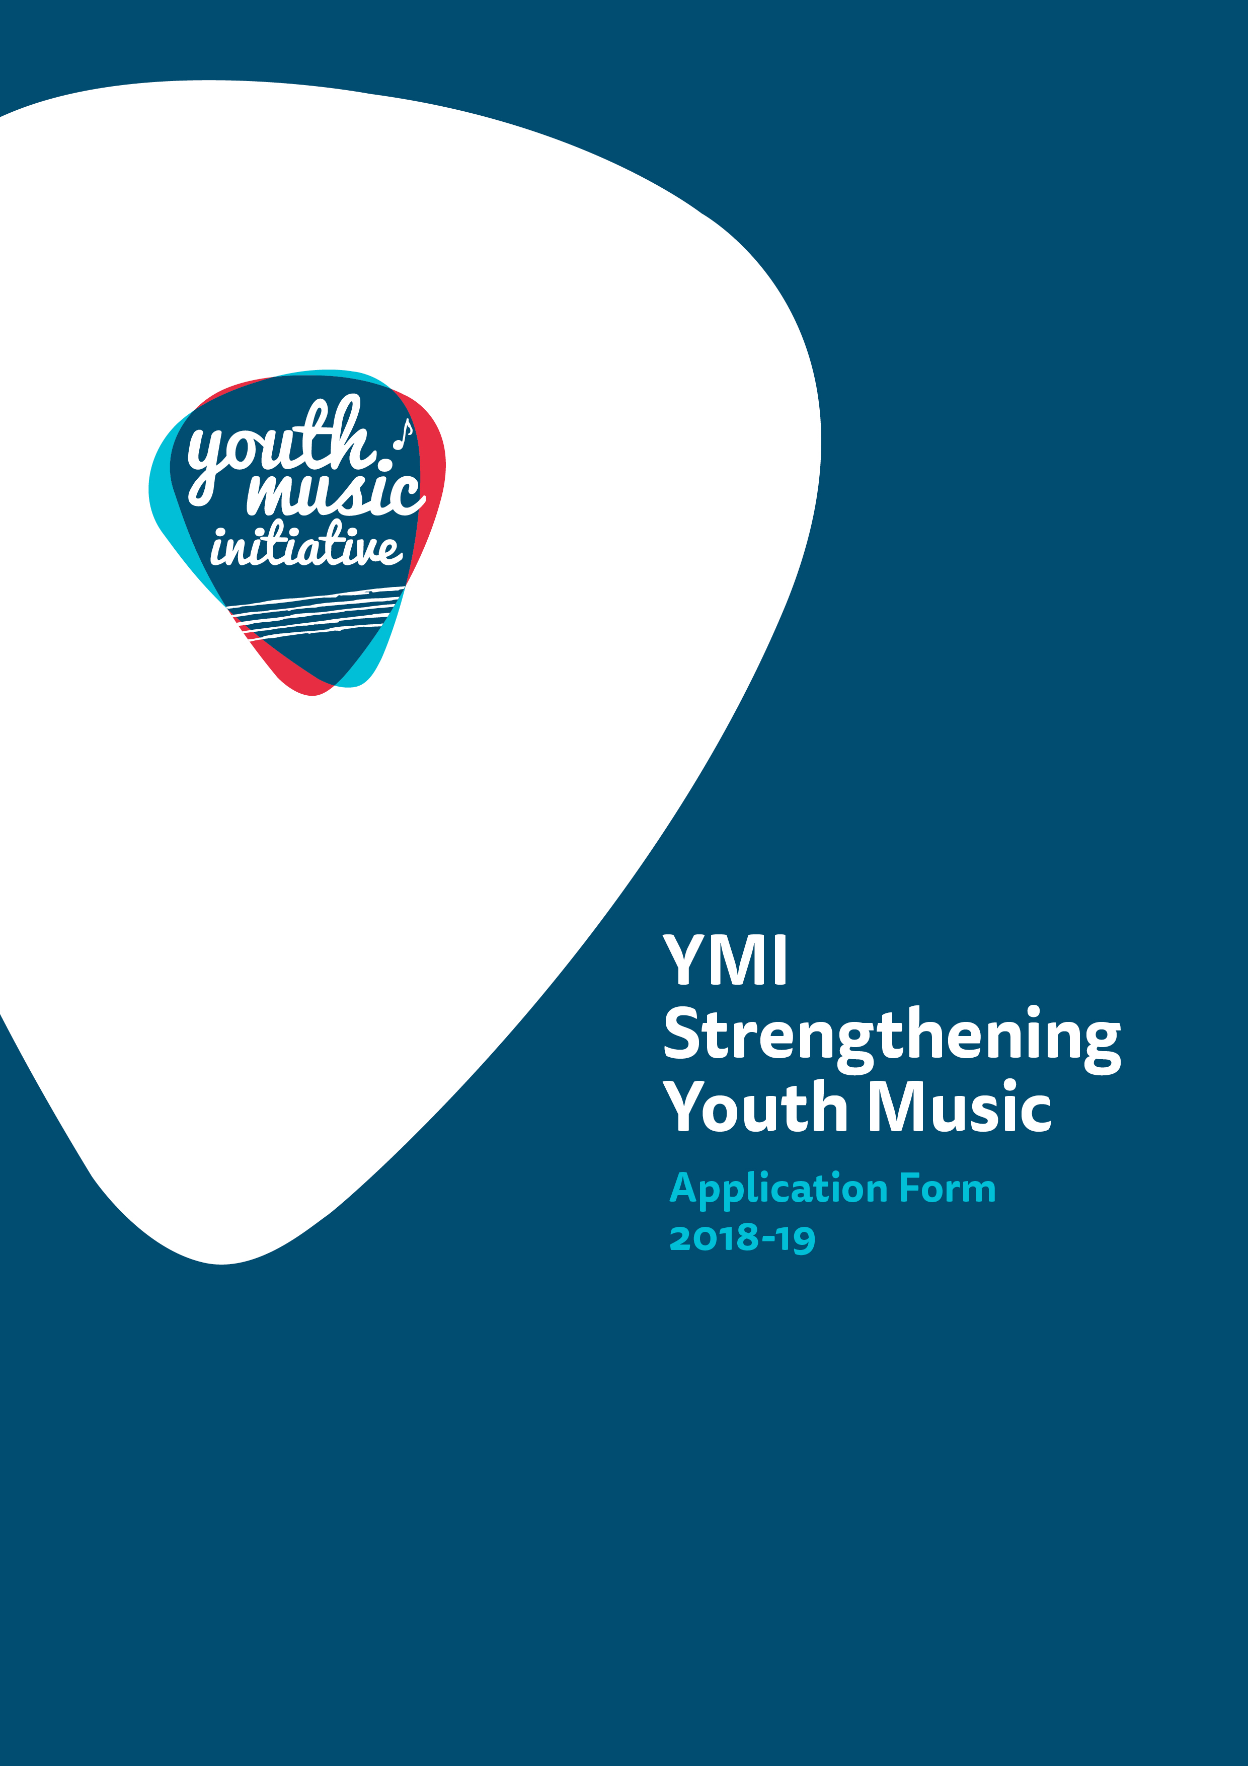

Application Form for
Youth Music Initiative
Strengthening Youth Music

Advice and Information
Please read the Strengthening Youth Music Guidelines before making an application. If you have any general enquiries about the application process, guidelines or application form please contact us as follows:
Email: enquiries@creativescotland.com
Telephone: 0345 603 6000* (10am-12pm & 2-4pm, Mon – Fri)

Alternative Formats, Languages and Access Support
Creative Scotland is committed to offering clear and accessible application processes and programmes that are open to everyone. On request this information is available in alternative formats including translations. We offer access support to disabled applicants, tailored to individual requests. Support includes Sign Language Interpreters for meetings and scribing support for dyslexic applicants. Officers can offer advice to new applicants and support them to make an application. The Equalities Team can offer additional one-to-one support to applicants with access requirements. Please note we will accept applications and supporting materials which are written in English, Gaelic or Scots.

If you have any general enquiries about the application process, Guidance or Application Form, please contact our Enquiries Service:
Email: enquiries@creativescotland.com
Telephone: 0345 603 6000* (10am-12pm and 2-4pm, Mon–Fri)

* Please note: Calls to our 0345 number are charged at the same rate as calling national 01 or 02 numbers. Approximate charges are up to 9p per minute from landlines and between 3p - 55p per minute from mobiles. However, calls to this number are also part of inclusive allowances. Please check with your phone line provider for exact charges.

Section A: For all applicants, please confirm the following:

Have you have read the Strengthening Youth Music Guidelines before completing this application form? (Delete as appropriate) | Yes
 | No
Are you applying as an Individual or an Organisation?  (Delete as appropriate) | Individual
 | Organisation
Please confirm that you have read and understood Creative Scotland’s Funding Privacy Notice before completing this application form? (Delete as appropriate)  Please note that you must answer these questions for your application to proceed | Yes
 | No

Section B: Contact Information
If you are applying as an Individual, only fill in Part 1.
If you are applying as an organisation, please fill in Part 1 and Part 2.

PART 1:
Name of Applicant
Lead Contact Name and Position (if appropriate)
Address
Postcode
Telephone number
Email address
Web address
PART 2:
Trading Name of Organisation
Full Legal Name of Organisation (if different from above)
What type of organisation are you? (Please type an X in the box in the right hand column)  (We need this information so we can determine if you are eligible to apply for Youth Music Initiative funding.  We also need the information so we can monitor our decision making and report to the Scottish Government on the types of organisations we fund.) |  | Company Limited by Guarantee
 |  | Company Limited by Shares
 |  | Scottish Charitable Incorporated Organisation (SCIO)
 |  | Community Interest Company (CIC)
 |  | Local Authority
 |  | Cultural and Leisure Trust
 |  | Public Sector Agency
 |  | Trust or Foundation
 |  | Other (please specify)
Are you a registered company? (Delete as appropriate) |  |  | Yes
 |  |  | No
If you are a registered company, please provide your Registered Office address and Company Number
Are you a registered charity? (Delete as appropriate) |  |  | Yes
 |  |  | No
If you are a registered charity, please provide your Registration Number
Please tick this box if you wish to receive email updates from the Youth Music Initiative and Creative Scotland.

Section C: Project/Application details

Project/Activity Title
Please detail the activities you intend to undertake with this funding. If you are successful in receiving funding, we may use this information in any publicity we produce about your project or activity (100 words max)
When will the project / activity start?

When do you expect the project / activity to end?
Where will the project / activity take place?  (Please tell us as much information as you can about where your project/activity will take place. We will expect you to fill out at least one of these boxes, but please complete as many as are applicable. | Post Codes:
 | Local Authority areas:
 | Outside Scotland:

Programme Specific Questions
Your answers will be used to assess your application against the guidelines and criteria.

1. There is one mandatory outcome for this fund. Please select one other outcome for your project by clicking on the text “choose an item” and then choosing your outcome from the drop down list. Then describe how the activity will deliver these outcomes. (200 words per outcome max.)
Please refer to the Outcomes section in the guidelines.
People delivering youth music develop their skills and confidence (mandatory outcome)
Choose an item.

2. Please provide details of your programme of activity that will be delivered, including timelines, key dates and activity plans (if possible).

3. Please describe how your project will tackle inequality by providing support to the sector to widen access and improve provision. Please refer to at least one of YMI’s priority groups. (200 words max).
Please refer to the priority groups in the guidelines.
4. Please describe how you have identified a need for this project. (200 words max)
For example, what observations, evidence or feedback have led you to make this application.
5. Please describe how your project will improve youth music infrastructure and/or the opportunities the sector offers to young people. (200 words max)

6. Please describe how you have consulted with young people (if possible) and stakeholders to develop this project. (200 words max)
7. Please describe how the project will be advertised and how you will reach participants from your target audience. (200 words max)
8. Please outline how you will increase your impact by extending the project’s benefits to a wide range of practitioners. (200 words max)
For example, how can you broaden the participant group, connect formal and informal sectors, share learning and resources, or develop this project as a model.
9. Please describe how you will monitor activity and evaluate if the outcomes described in Question 1 have been achieved, including the methods and indicators you will use. The outcomes selected in this section must match the outcomes selected in Question 1. (200 words max for each outcome)
People delivering youth music develop their skills and confidence (mandatory outcome)
Choose an item.
10. Please provide a brief track record of delivery, highlighting any projects or work you feel are specifically relevant to this project. (200 words max)
11. Please describe how the project will be managed, including staff roles and responsibilities, and details of project partners and their roles. (400 words max)
12. Risk Assessment: define any key risks and how you plan to mitigate them. (200 words max)

Section D: Budgets and funding

What is the total budget of the project / activity? | £
What is the funding you require from Creative Scotland? | £
What percentage is this of the total budget? | %
How much cash match funding is either guaranteed or pending? | £
What percentage is this of the total budget? A minimum of 10% cash match funding must be either guaranteed or pending | %

Please submit a separate one page budget, ideally using a spreadsheet such as Excel

Please refer to the Strengthening Youth Music Guidelines for guidance on completing the budget.

Please note budget figures should be rounded up to the nearest £.

Have you completed a one page A4 budget? (Delete as appropriate) | Yes/No

Please ensure you also complete the Income Table on the following page.

Income Table
This information will be used internally to help inform our work and to report to government and stakeholders.

Type of Funding | Name of Funder / Source of Income | Cash or In-kind | Conditional or Guaranteed or Pending | Amount of Funding / Income | % of Total Project Cost
PUBLIC FUNDING
Creative Scotland
Local Authority
Local Enterprise Companies
Broadcasters
Other Lottery
Own Resources (cash and / or in kind, please specify)
Other
PRIVATE FUNDING
Trusts & Foundations
Companies
Individuals & Fundraising
Other (please specify)
Own Resources (cash and / or in kind, please specify)
EARNED INCOME / OTHER (please add rows as required)
e.g. Box Office
Please specify
Please specify
TOTAL |  |  |  |  | 100%

Section E: Essential and supporting material
Please detail all the supporting material you are submitting (and where Creative Scotland can access it).

Please refer to the Strengthening Youth Music Guidelines for guidance on what supporting material is required.

Please detail the supporting material submitted | Please advise if the material has been attached to the application or where we can access it
Copy of your constitutional documents (or, Unique Tax Reference Number (URN) if you are applying as an individual) and Equal Opportunities Policy (Essential if applying to Creative Scotland for the first time)
One page A4 budget (Essential)
A copy of your organisation’s Child Protection Policy (Essential)
CV or detailed biography of project staff, artist, professionals, indicating experience relevant to their role in this project (Essential)
Letters or emails from partners outlining support and their involvement in the project (Optional)

Section F: Statement of Acceptance
PLEASE STATE THE NAME OF THE PERSON WHO HAS COMPLETED THE FORM. THIS PERSON MUST BE AN AUTHORISED SIGNATORY OF THE COMPANY OR ORGANISATION APPLYING OR, IN THE CASE OF AN INDIVIDUAL APPLICANT, BY THE PERSON NAMED IN SECTION B, PART 1, OF THE CONTACT DETAILS.
I hereby confirm that the information in this application submission including the supporting documents is true and correct and I acknowledge that it is my responsibility to inform you immediately of any changes which could affect the interpretation or context of the application, and I confirm I will undertake to do this.
I acknowledge that the terms and conditions of this application and any other information supplied and discussed regarding this application, the assessment and decision making process, or in connection with this transaction as a whole (“the Confidential Information”) is and shall remain strictly confidential. I confirm that I shall not disclose to any third party or make public the Confidential Information without Creative Scotland’s prior written approval.
I acknowledge that Creative Scotland will endeavour to keep all information provided securely, but as a Public Authority in terms of the Freedom of Information (Scotland) Act 2002, may be required to disclose certain information under the Act. Where I stipulate at the time of providing information to Creative Scotland that I believe the information should be considered exempt from disclosure under that Act, and a request to Creative Scotland is subsequently made for disclosure of same or all of that information, Creative Scotland will endeavour to discuss such disclosure with me prior to making its decision. I do, however, accept and acknowledge that the ultimate decision on disclosure rests solely with Creative Scotland regardless of any prior statements or requests I have issued.
If any of the information I provide is classed as Personal Data under the Data Protection Act 1998; the General Data Protection Regulation (EU) 2016/679 of 27 April 2016 (GDPR); and any legislation supplementary to the GDPR introduced in the United Kingdom (the "Data"), I hereby consent that Creative Scotland may disclose said Data, within and outside of the European Economic Area, for the purposes of producing and submitting any statistical information and reports or as otherwise required by law or by any regulations and other rules to which we are subject.
I confirm that all cash and in-kind contributions from the company or my own personal resources stated in the funding plan section of this application form are correct and that I have the authorisation to allocate the sums stated and I am responsible for ensuring that adequate resources will remain available to meet these requirements. In the event of any changes to the sums indicated I will provide a signed letter of confirmation.
I acknowledge that Creative Scotland is obliged to comply with Money Laundering Regulations 2007 and the Proceeds of Crime Act 2002 and I will, if requested, provide ID verification from any investor or myself, where appropriate, to meet compliance requirements.
I acknowledge that once Creative Scotland have confirmed the Offer of Funding in writing (via email) that Creative Scotland have the right to publicise their Offer of Funding on the Creative Scotland website and through other Creative Scotland information channels. I understand that Creative Scotland’s Offer of Funding does not place Creative Scotland under any obligation to release funds until such time as all contractual negotiations are complete and Creative Scotland’s Conditions Precedent have been met and their Funding Agreements signed off.

I confirm that I will not make any public statements (or allow others to do so on my behalf) regarding Creative Scotland’s Offer of Funding until such time as Creative Scotland has authorised and approved the form and content of any public statement.
I confirm that I have the power to accept the award under the conditions set out in the Creative Scotland Guidelines and in this Application Form.
I declare that I have read and understood the Creative Scotland Guidelines, this Application Form and the Conditions of Funding of Creative Scotland.

I hereby confirm acceptance of the above Statement of Acceptance and all related documents. (PLEASE TICK THIS BOX TO CONFIRM ACCEPTANCE)

I hereby confirm that all Project Staff / Trainees (if applicable) engaged in this project will be members of the Protection of Vulnerable Groups Scheme administered by Disclosure Scotland before the project begins. (PLEASE TICK THIS BOX TO CONFIRM)

……………………………………………
Name of Authorised Person

……………………………………………
Position of Authorised Person

……………………………………………
Date

Please submit your completed application form to: ymistrengthening@creativescotland.com

Please now complete your Equalities Monitoring Form and email it along with your application form. Please note: the Equalities Monitoring Form is anonymous and will be processed separately from your application.

