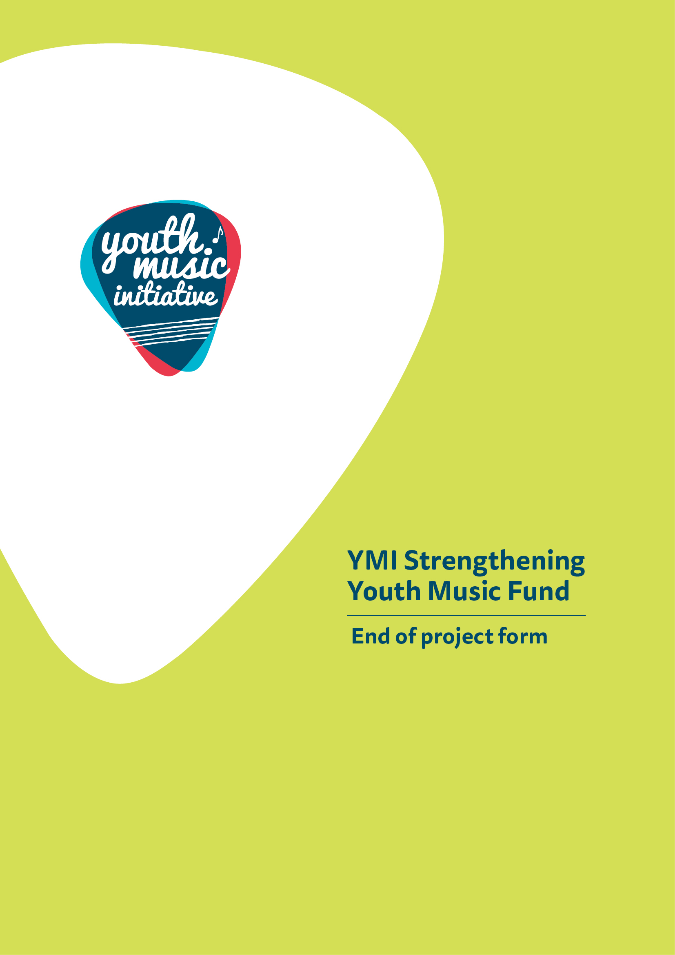

End of Project form
Strengthening Youth Music Funds

About You

Name of Applicant (Organisation)
Lead Contact Name
Grant reference number (you will find this on the grant offer letter)
Start date for YMI funded activity (this should be your actual start date not your planned start date)
End date for YMI funded activity
Activity

- Did you deliver all of the activities that you intended to deliver, as set out in your application form? (For example, the intended number of sessions).  Please tick the appropriate box | Yes | ☐
 | No – more than intended | ☐
 | No – less than intended | ☐
2. Please briefly (in a maximum of 250 words) tell us what activity you delivered.

3. Please briefly (in a maximum of 250 words) tell us if any of your activities differed significantly from your application and, if so, why?
Please do not include alterations to delivery that were brought about due to COVID-19. There is a separate section at the end of this form to note the impact of COVID-19 on your activity.

4. Please state how many organisations and/or individuals benefited from your project.

Organisations

Individuals

Please list the organisations/partners that benefited from your project

5. Please describe how your project has contributed to strengthening the youth music sector. You might want to consider increased partnership working between formal and informal groups, local or national networking, pooling of resources.

Jobs, Trainees and Volunteers

- How many posts were funded (or part funded) through YMI?
Number of posts
Permanent – full time
Permanent – part time
Temporary – full time
Temporary – part time
- How many volunteers and trainees were involved in supporting YMI activity?
Volunteers
Trainees

- How many people have benefited from training and continuing professional development linked to your YMI activity?

Outcomes
We are very keen to know what difference your YMI work is making. This is a very important part of this form and we will be increasingly looking to strengthen the information about outcomes over the coming years. One of these should be the mandatory outcome for the strand you applied to.

- Think back to your application for YMI funding, where you were required to choose the outcomes you aimed to bring about for each of your projects.

For each of the outcomes you selected, please provide evidence to indicate the difference your work has made.

This should be evidence gathered from young participants, deliverers, partner organisations and other relevant stakeholders. It could include surveys, discussions, emails, videos, case studies and observational evidence.
Outcome 1: People delivering youth music develop their skills and confidence (mandatory outcome)

What evidence do you have about progression towards this outcome?
Outcome 2: (Insert title)
What evidence do you have about progression towards this outcome?
- Has your work also contributed to wider outcomes not covered above? | Yes ☐  No ☐
- If yes, which of the other YMI logic model outcomes has it contributed to?

Outcome |  | If your work has contributed (and isn’t covered above in Q12) please briefly tell us how
Young people have more opportunities to take part in enjoyable and quality music making opportunities
Young people who would not normally have the chance to participate take part in music making opportunities
Young people develop their music and music making skills
Young people develop their skills for life, learning and work
Young people increase their awareness of music and culture across Scotland, the UK and the world
Young people influence or lead youth music opportunities and have their voice heard in design and delivery
People delivering youth music develop their skills and confidence
Organisations in the music sector and beyond work together to strengthen the youth music sector for the benefit of young people
12. If yes, has your work contributed to other wider outcomes not listed above? Please tell us how.

COVID-19

13. Please give an outline of any changes to planned activity (including dates if applicable) and indicate whether activity was cancelled, or replacement activity delivered.
14. Please outline the impact that these changes had on your organisation, core, and freelance staff.
15. Please use the space below to tell us any further information you would like to share in relation to the impact of Covid-19 on your organisation and the young people you work with.

Signed: | Date:

Income and Expenditure

Please provide the following summary budget information and send a certified financial statement using the attached form (See Appendix 1).

Forecast total project expenditure | £
Actual total project expenditure | £
If there were any significant changes (over 10% variation) between actual and forecast figures, please detail these below. If costs increased, please tell us how you managed the shortfall in the space below.

Please note: when the final amount of your grant is calculated, if the project has achieved a surplus of funds because costs have reduced or income from other sources has increased, we will reduce our final payment or ask you to repay any overpaid sums as appropriate.

Our Processes

16a. Did you find the application and funding process clear? | Yes ☐  No ☐
16b. Comments (please provide any comments about the application and funding process below)
17a. Did you find the monitoring and evaluation process clear? | Yes ☐  No ☐
17b. Comments (please provide any comments about the monitoring and evaluation process below)

How to submit your end of project form

Please either attach your supporting evidence (photographs, videos, audio files) to your email to us, or let us know how you would prefer to share this type of information (e.g. through Dropbox or an online link to existing information).

For accounting and audit purposes, this form (and particularly the Certified Income and Expenditure statement in Appendix 1) must be physically signed off by the lead contact for the application as being a true and accurate representation of income and expenditure. A scanned or electronic version of this signature is acceptable.

Please now email your completed form (with scanned signature) to projectreporting@creativescotland.com

When we receive your report, we will log it and send it to your lead officer within the YMI team for checking, approval and sign off.

Appendix One: Certified income and expenditure statement

Name of Applicant (Organisation) |  | Grant reference:
Please include all income and expenditure, both cash and in-kind, using the headings given in your application form and in the same order. Where headings include a number of different types of expenditure, you should provide a breakdown showing how the figure has been arrived at. Please provide explanations of any significant variations between budget and actual (greater than 10%) in the Income and Expenditure section in the end of project monitoring report. If you need to use additional pages please include the grant reference number on each page.
Income |  |  |  | Expenditure
Source | Budget (£) | Actual (£) |  | Item | Budget (£) | Actual (£)
Total |  |  |  | Total
Total surplus/deficit on the project (actual income less actual expenditure): |  |  |  |  |  | £

Signed: Date:

Printed name: Position (if signing on behalf on an organisation):

Important information

Openness and accountability

Information supplied by you will be held in manual files. It will then be summarised and details transferred to a computer-based grants management system. Reports from the information you supply and from any comments made by external assessors and staff members are likely to be held on both manual and computer-based systems. The information you supply will be made available to those assessing any other grant applications you make.
Data protection
Data held on our grants management system is used for statistical and accounting purposes. We view your signature on your application form as acceptance of the use of your data outlined above.

